**CLOUD COMPUTING**

Kalpesh Gadge

ROLL_NO: 25



**CERTIFICATE**

This is to certify that Mr. / Miss/Mrs. **Kalpesh B Gadge** with Seat No.**25** has  successfully completed the necessary course of experiments in the subject of  **CLOUD COMPUTING** during the academic year **2020 – 2021** complying with the  requirements of **RAMNIRANJAN JHUNJHUNWALA COLLEGE OF ARTS,  SCIENCE AND COMMERCE**, for the course of **M.Sc. (IT)** semester

**CLOUD COMPUTING**

**Index**

|  |  |  |  |
| --- | --- | --- | --- |
| **SR.NO** | **PRACTICAL TITLE** | **DATE** | **SIGNATURE** |
| 1 | Implement cluster on Windows | **23-01-2021** |  |
| 2 | Developing application for Windows  Azure | **13-2-2021** |  |
| 3 | Implementing private cloud with Xen  Server | **2-01-2021** |  |
| 4 | Implement Search Engine Google App  Engine(GAE) | **6-02-2021** |  |
| 5 | Implement ESXi Server | **19-12-2020** |  |
| 6 | Native Virtualization using Hyper-V | **20-02-2021** |  |
| 7 | Implement Open Nebula | **16-01-2021** |  |
| 8 | Implement Big Web Service | **13-02-2021** |  |

**CLOUD COMPUTING**

**PRACTICAL: 1**

**IMPLEMENTING CLUSTER ON WINDOWS**

Install the VMWare Workstation. The Home page of VMWare Workstation looks like the picture below. To create a new Virtual Machine, click on “Create a New Virtual Machine”. In the “New Virtual Machine Wizard” select the “Typical” option. And click on “Next” button

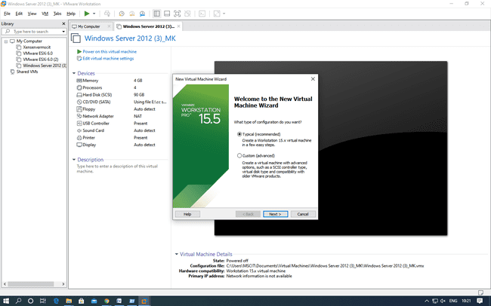

In the Next window, select the option Install Disc and click on Browse to select the windows server 2012 iso file and then click on Next.

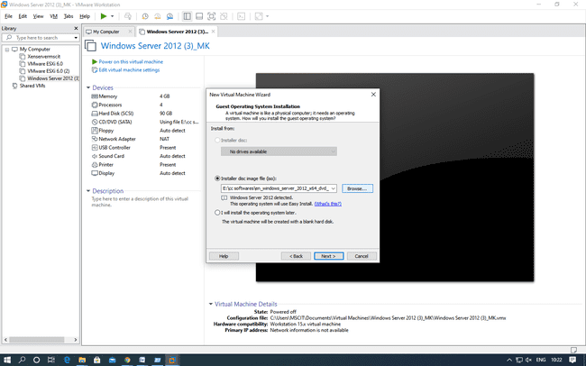

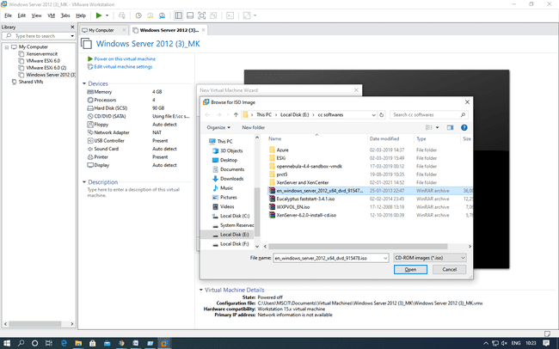

In this window, select the name of operating system and its version.

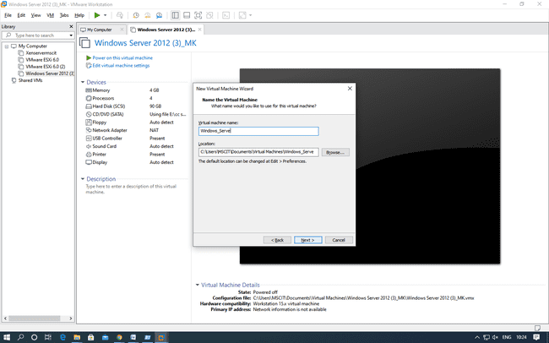

Click “Next”, And click on yes

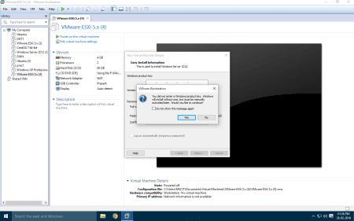

Choose “Store virtual disk as a single file” and Keep the memory size as 90GB. Click on “Next”.

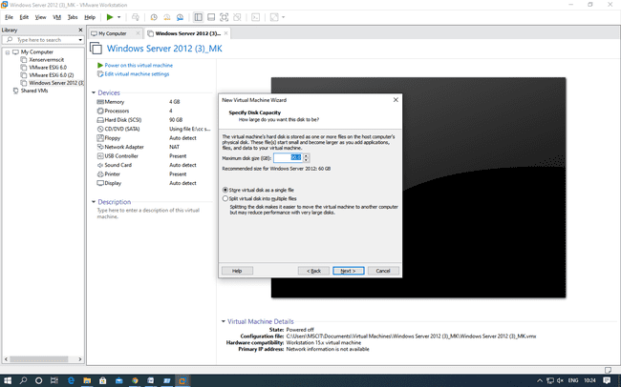

Click on Customize hardware and then go to memory under Device and make it to 2GB. Power on the virtual machine by clicking on “Power on this virtual machine”.

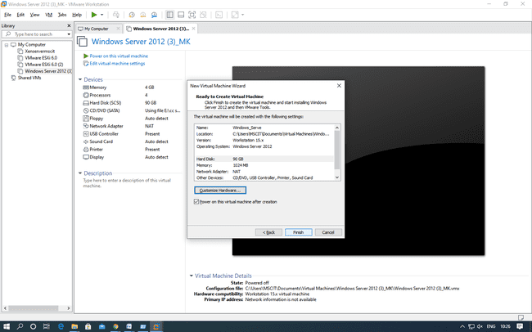

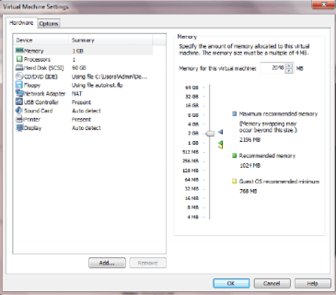

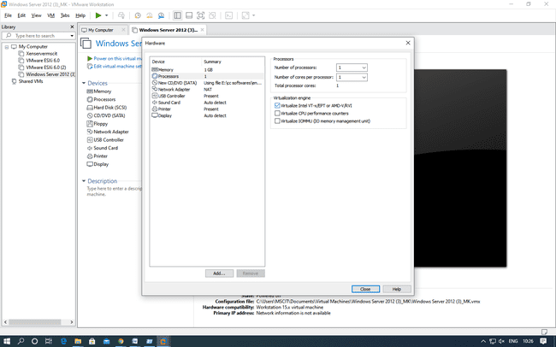

Copying of System Files will start.

After copying files it will automatically start.

If installing on the Virtual Machine like VMWare then you need to click on the menu as show in the next screen to sign in as Admin.

Enter Below password:- Admin12345

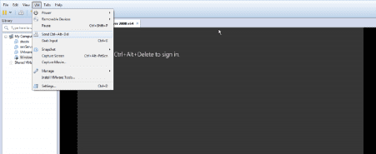

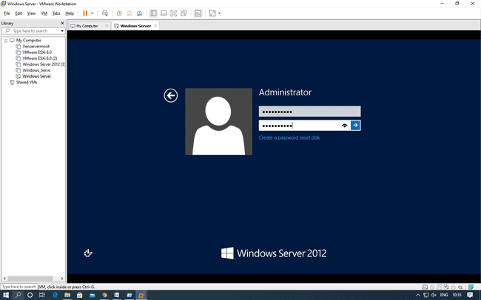

To make the current system a Domain Controller click on “Add Roles and Features” under the “Manage” menu at the top of the screen and get the “Add Roles and Feature Wizard

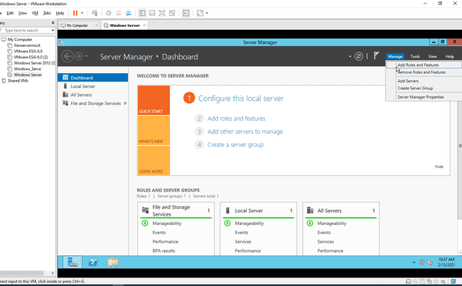

In Add Roles and Features Wizard, under “Before you Login” no changes – click next

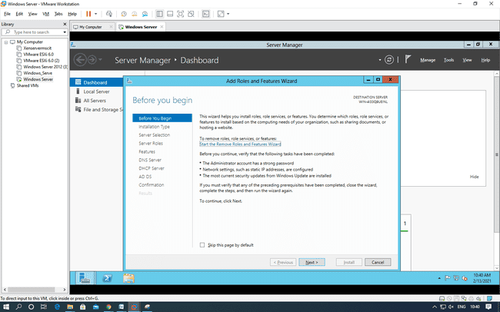

Under “select installation Type” select “Role-based or feature-based installation” and click “Next” button.

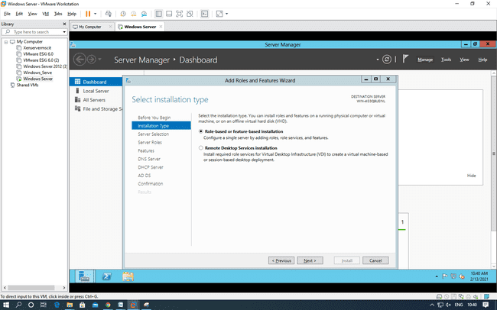

Under “Select Destination server” select “Select a server from the server pool” option and select the server as shown in the screen below and click “Next

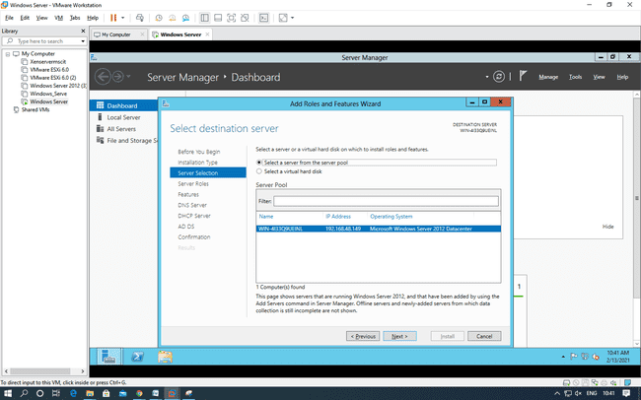

Click on “Active Directory Services”, “DNS” and “DNS” roles from the list of roles provided and click on “Add Features” button as shown in the screen. Add Features button will appear as you click on any of the roles. After selecting the Role click “Next”.

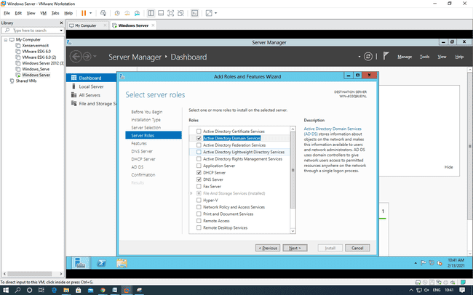

Under “Select Features” select “Failover Clustering” and “.NET Framework 3.5 Features” and click “Next”.

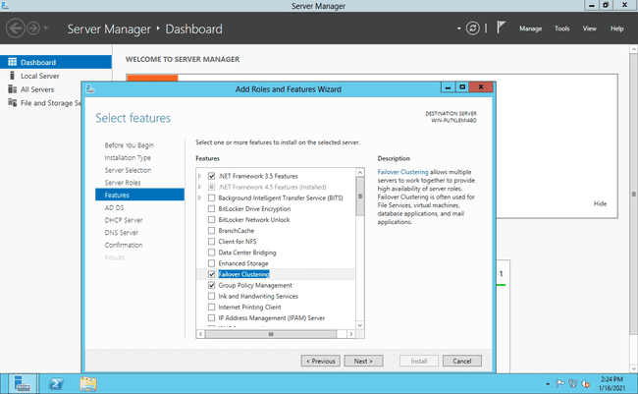

You will see the “Confirm Installation selections” then click on link “specify an alternate path”. As shown in below two screens.

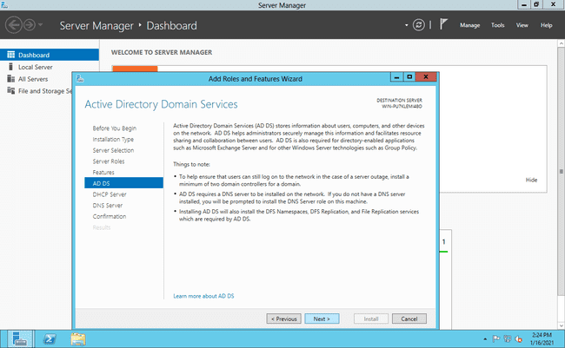

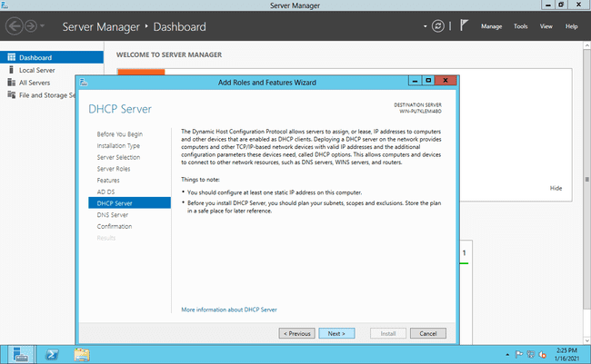

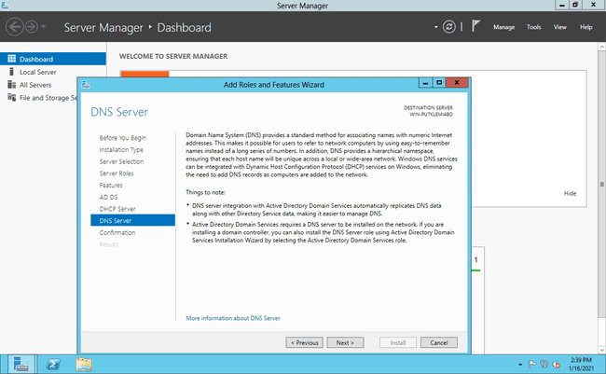

In confirmation tab,..click on spificy alternate path and Now, For path specification Go to menu VM->use Iso image file of windows server 2012->Ok Then, Go to File Explorer->Computer -> select the DVD->VIEW FILE-> SOURCES->SXS:

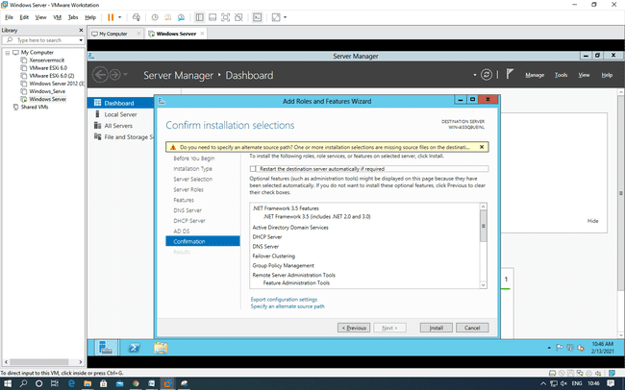

Copy the path and paste it.  
Now click on Install

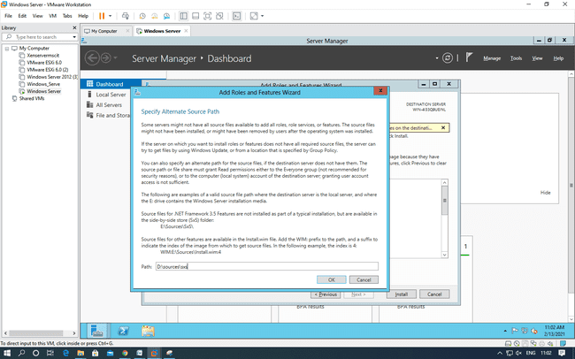

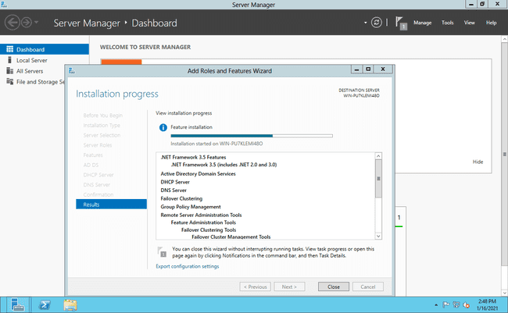

PROMOTING AS DOMAIN CONTROLLER

After installation Go to the “ADDS” shown on the left side in the server Manger Dashboard as shown in next screen and click on More, then Click on “Promote this server to a domain controller”.

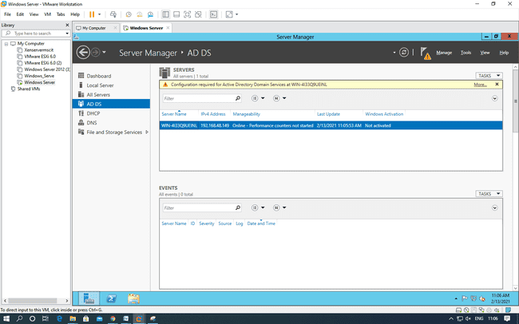

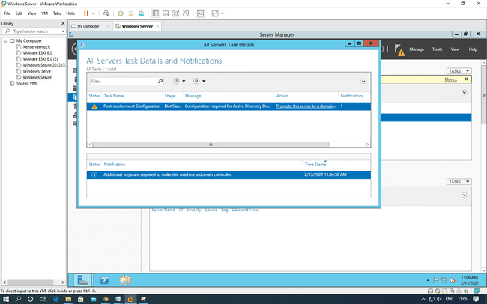

Choose “Add a new forest” option in the “Active Directory Domain services Configuration Wizard” window. Enter the Domain Name “rjcollege.com” as shown in the screen and click “Next”.

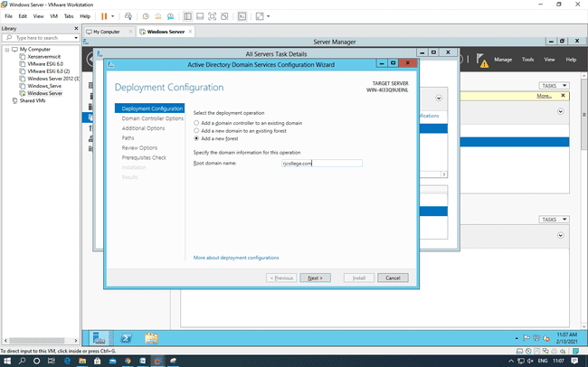

Under “Domain Controller Options” enter the alphanumeric password for the “Directory Services Restore Mode (DSRM) PASSWORD”. Preferably use the password given to the Administrators account.

Password:- Admin12345

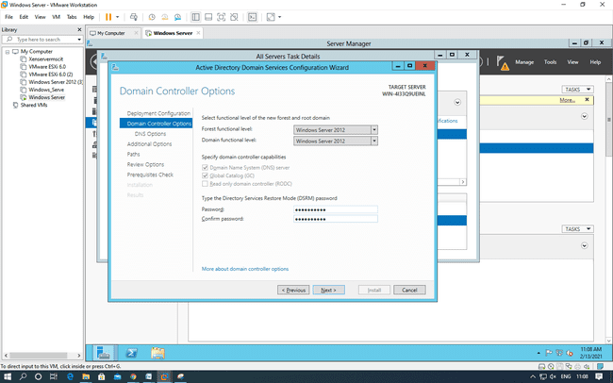

Click “Next”

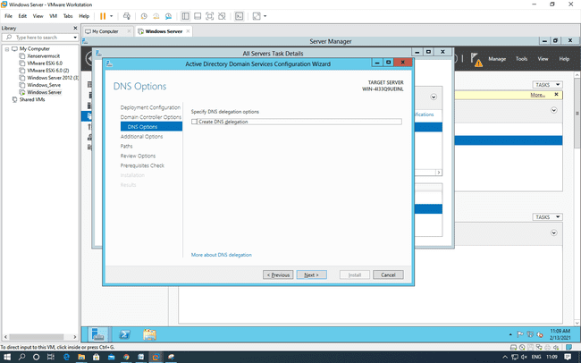

The NetBIOS Domain Name appears here automatically. Click “Next”.

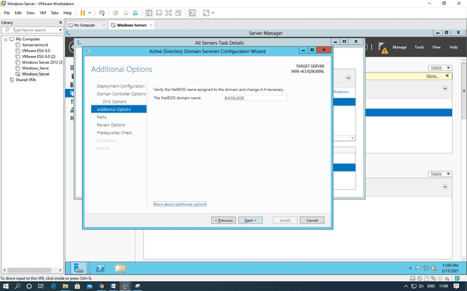

Click “Next”

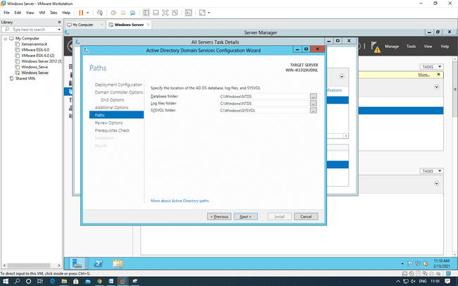

Under “Review Options” it shows us whatever we have selected for the Domain Controller.

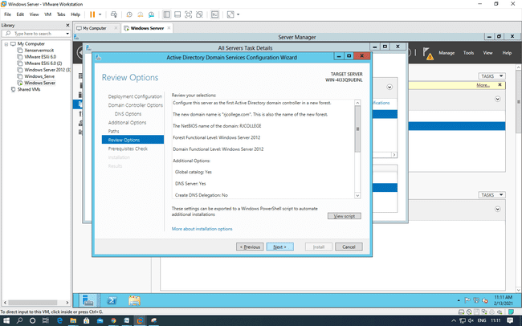

It checks for all the Prerequisites required to create a Domain Controller under “Prerequisites Check”. Click on “Install” button.

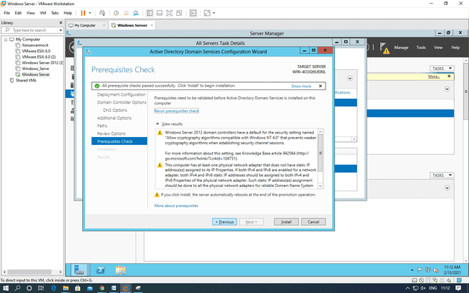

CREATING FAILOVER CLUSTER

Click on the “Failover Cluster Manger” under the tools menu to get the following screen.

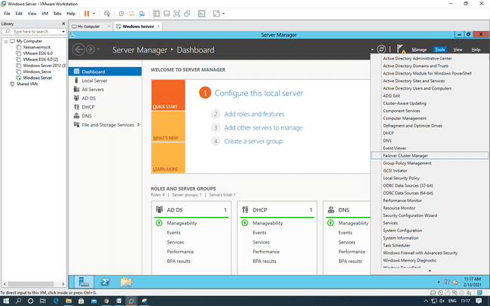

Click on “Validation Configuration” to open the “Validate a Configuration Wizard” by clicking on the “Validate Configuration” under the Management section at the bottom or right side of the screen. The nodes to be added must be validated prior to add in the cluster. Click “Next”.

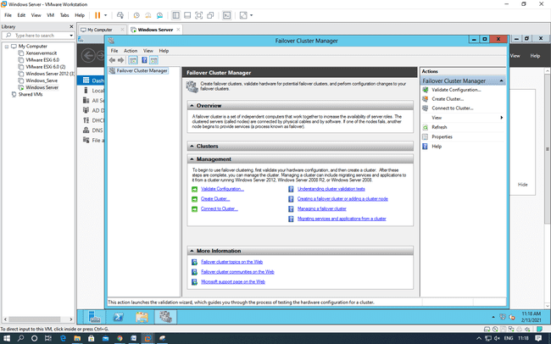

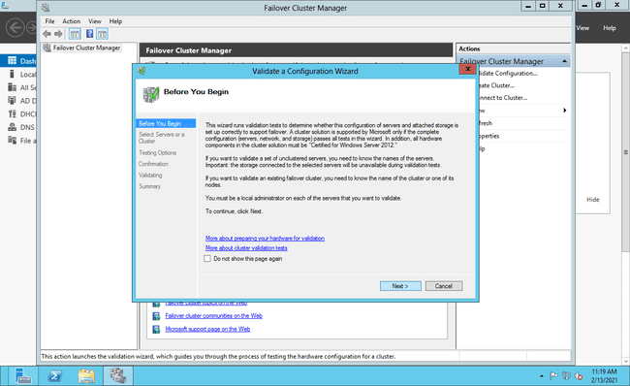

In this screen, click on Browse button and then Advanced for finding the domain node. As shown in below screens.

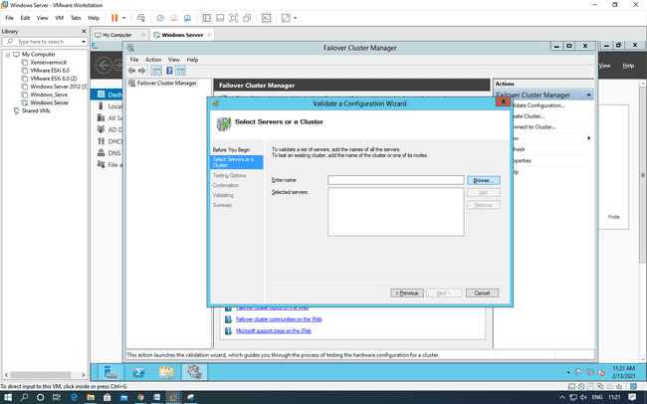

Click on advance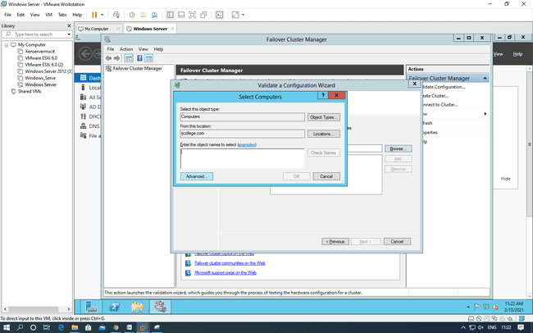

Click on Find now

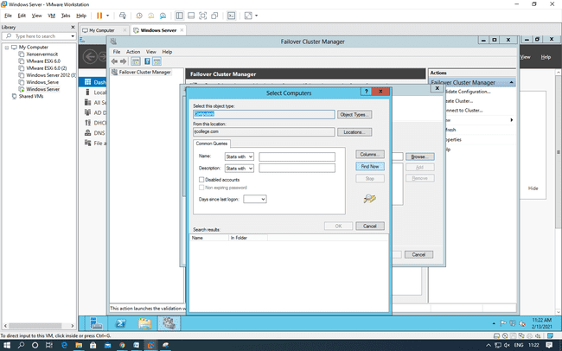

Select you server and click on OK.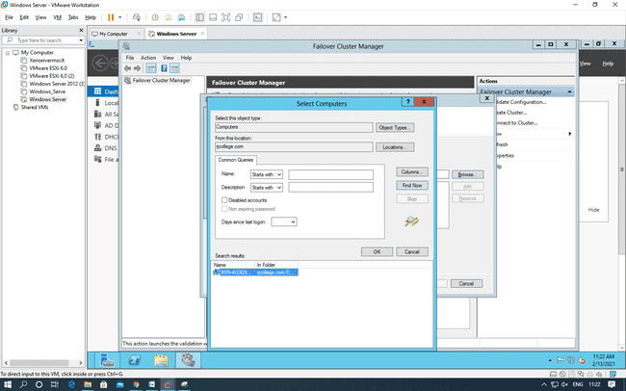

Click on run all test and then Next

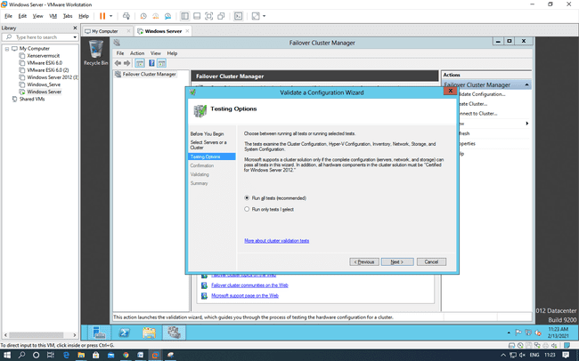

Choose “Run all the tests(recommended)” and click “Next” and then it will ask for the confirmation click “Next”. It will start all test validation.

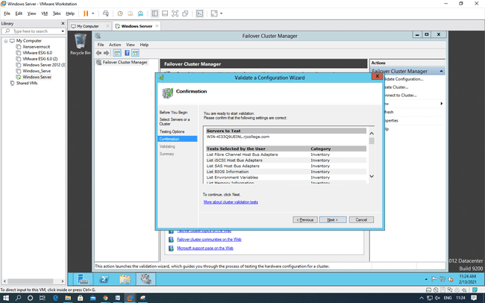

After completion it will display the summary report as shown below. If there are any errors can be seen here and you will not be allowed to create the cluster. As shown in the screen we can see that the nodes are validated. Click on finish.

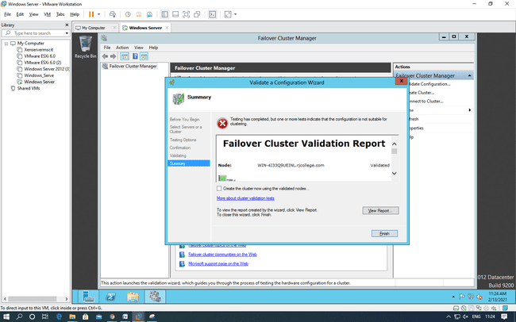

After validation completion you will create the “Create Cluster Wizard” click Next.

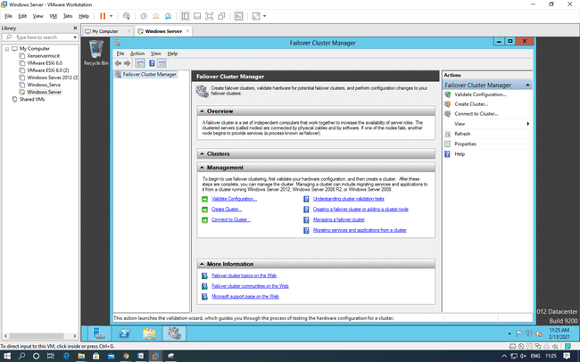

Click next

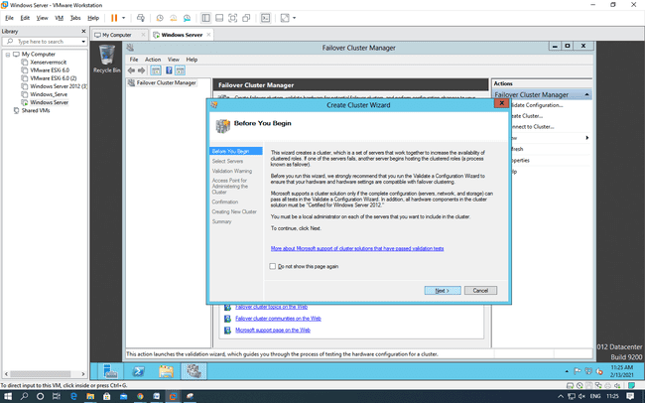

Specify the Cluster name. Cluster name here should be the NetBIOS name of the Domain Controller, so here it is RJC_Node. Click next

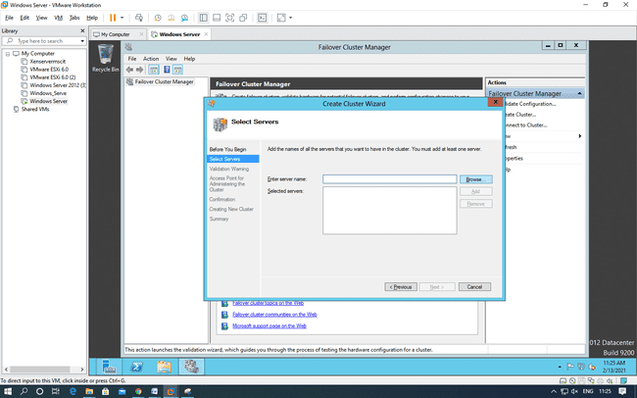

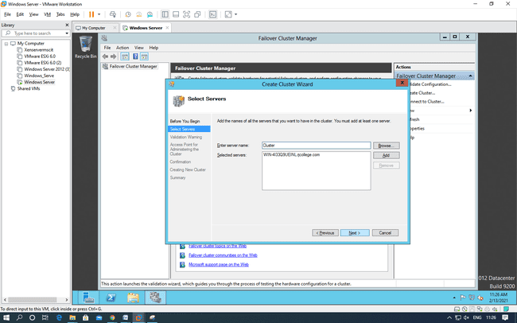

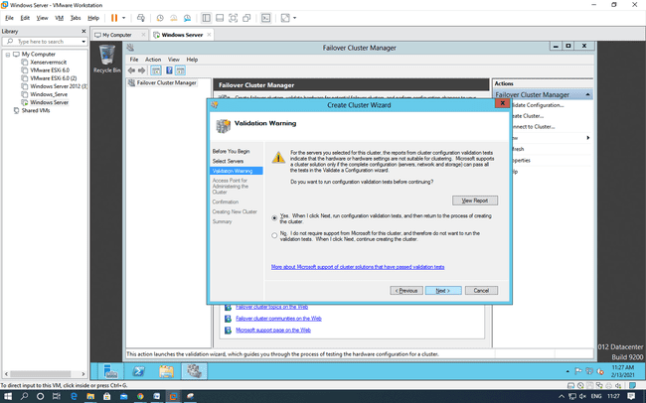

It will ask for the confirmation of cluster Creation. Click “Next”.

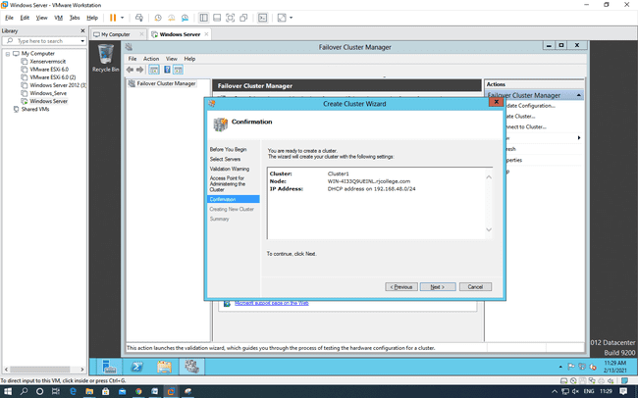

If the Cluster creation is successful you should see the following screen that shows a message “You have successfully completed the Create Cluster Wizard”

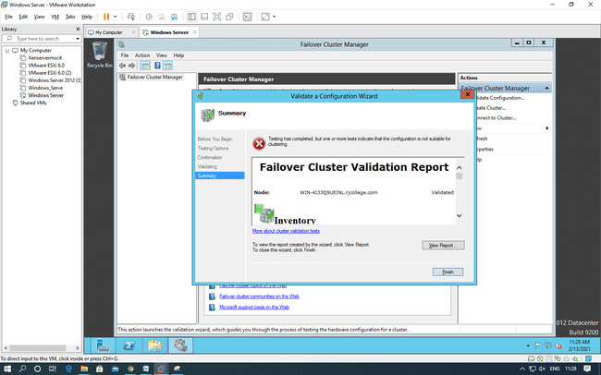

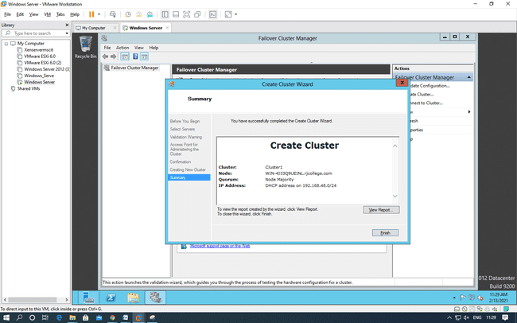

After cluster gets created you can see the cluster on the left side as shown in the screen below.

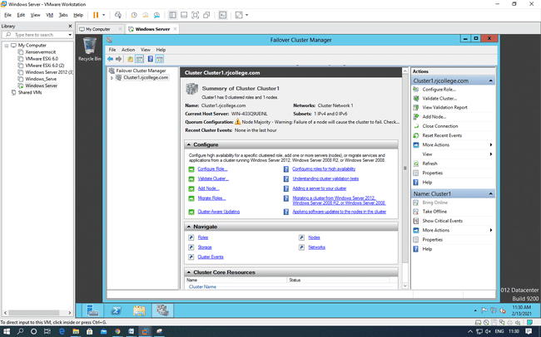

**Practical 2**

**DEVELOPING APPLICATION FOR WINDOWS AZURE**

To develop an application for Windows Azure on Visual Studio install the “Microsoft Azure SDK for .NET (VS 2010) – 2.8.2.1”

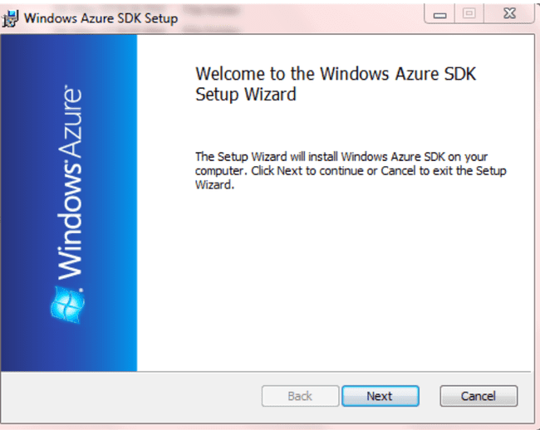

Accept the license and Click on Next.

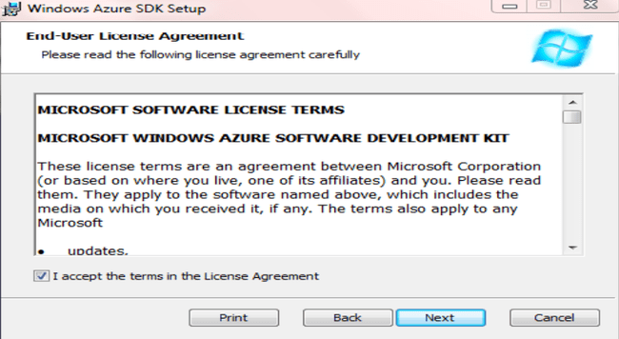

Click on Finish

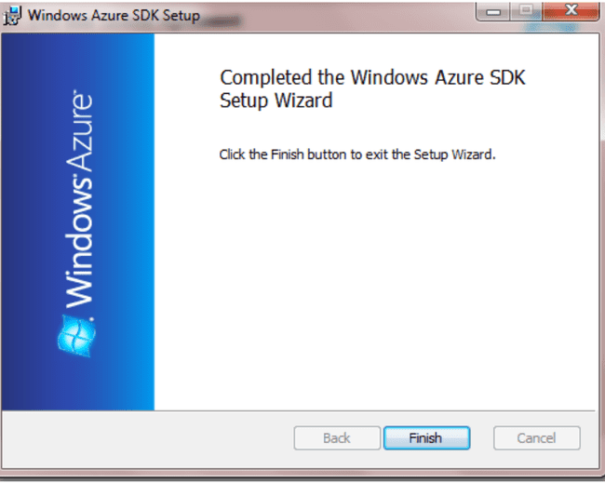

Step2: Turn windows Features ON or OFF: Go to Control panel and click on programs.

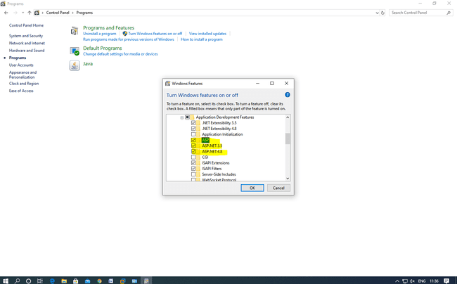

Now, Start the visual studio 2010 and Go To File->New->Project

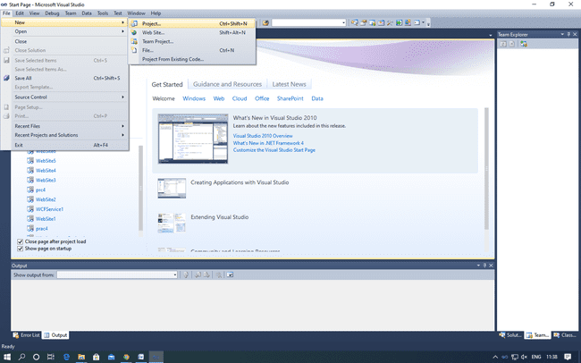

Add asp.net roles

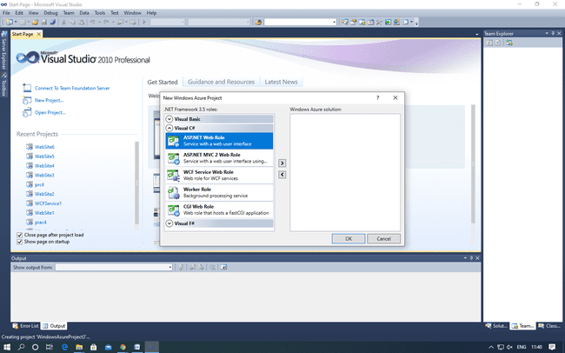

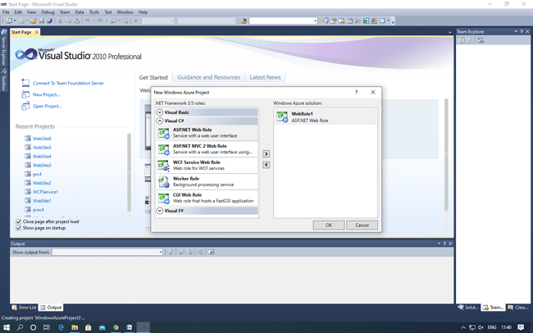

Create a web form

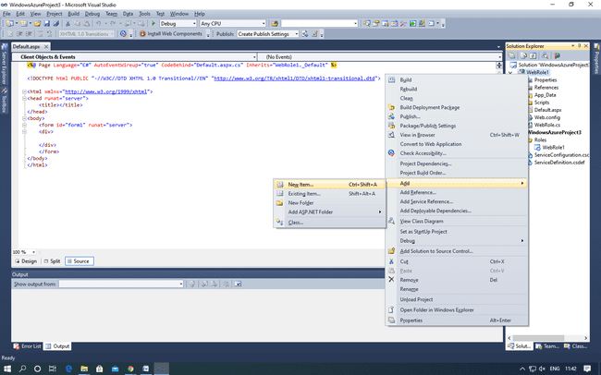

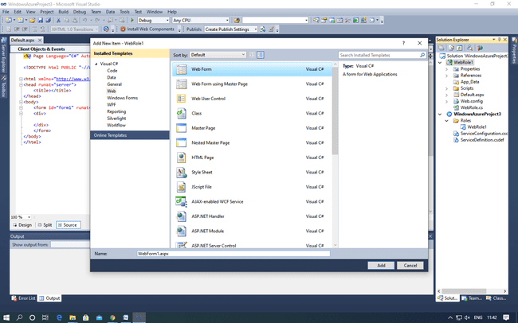

Run the website

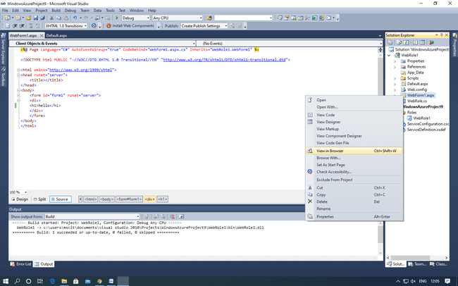

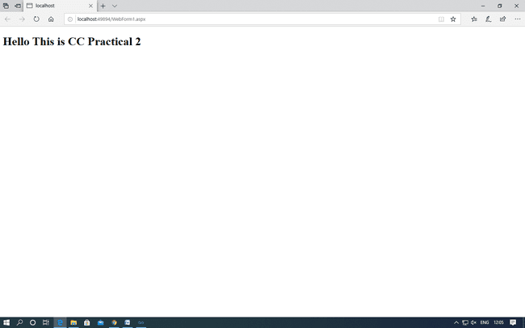

**PRACTICAL: 3**

**IMPLEMENTING PRIVATE CLOUD WITH XEN SERVER**

Open VMware Workstation – And select Create a New Virtual Machine

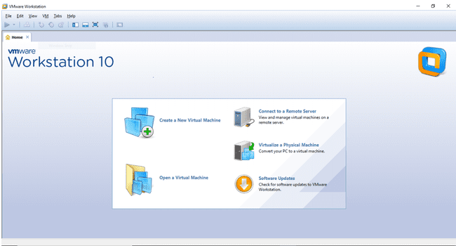

Select Typical and click Next

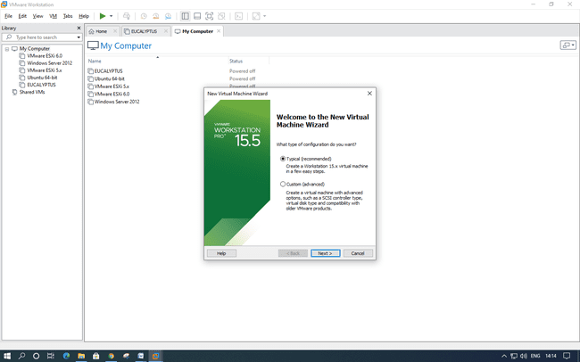

Select Installer disc_image file(ISO). Click Browse - XenServer Iso File – For Example “D:\ccpraxrj\XenServer-6.2.0-install-cd.iso” And click on next

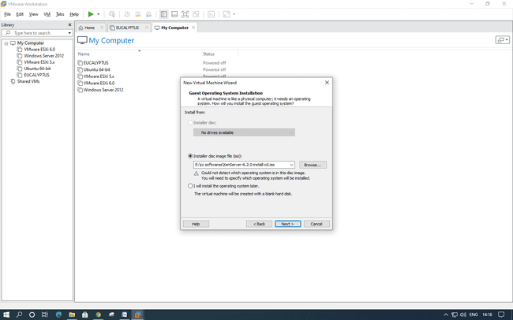

Select Guest Operating system as Linux. Version as Ubuntu. Click Next.

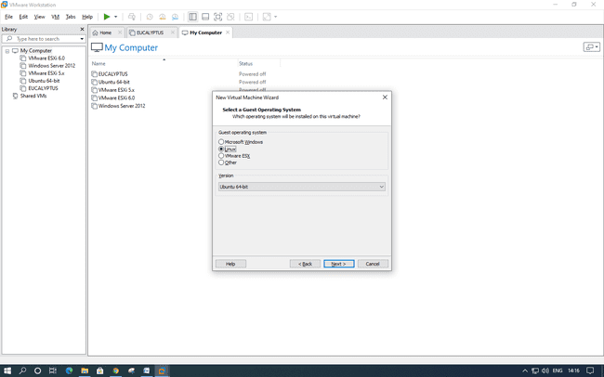

Give Virtual name – for Example “XenServer” and click on next

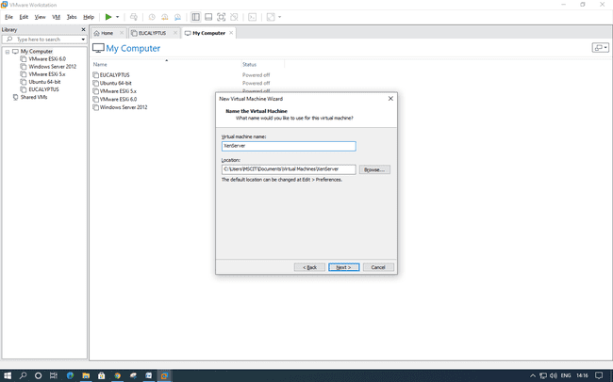

Change maximum disk size to 40 GB and check –Store virtual disk as single file

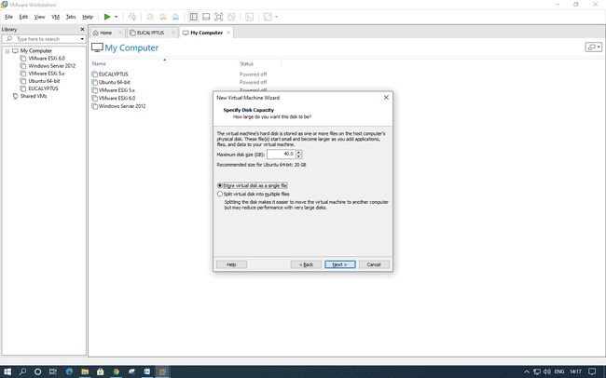

Click on Customize Hardware option

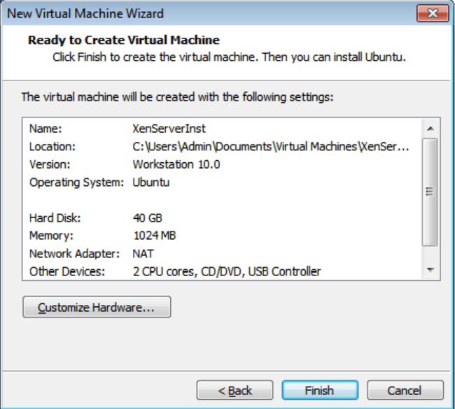

Change – Memory for this virtual machine to 2 GB and click on close

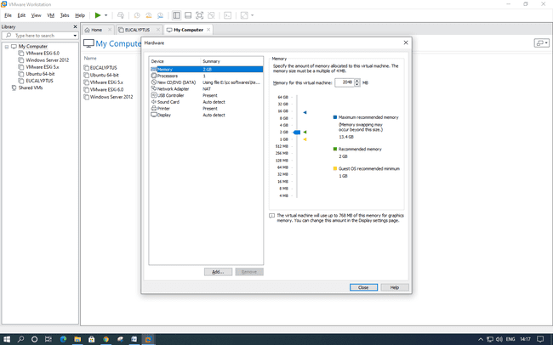

Click on Processer and select virtualize Intel VT

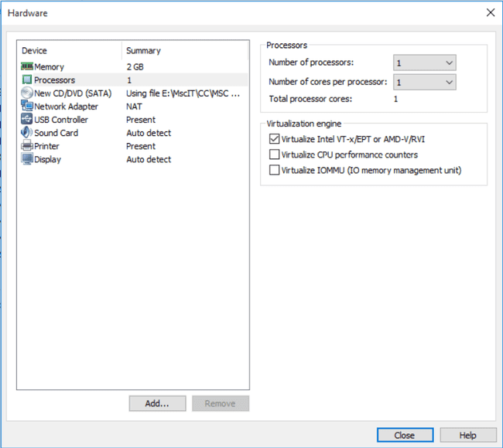

Click on Finish –

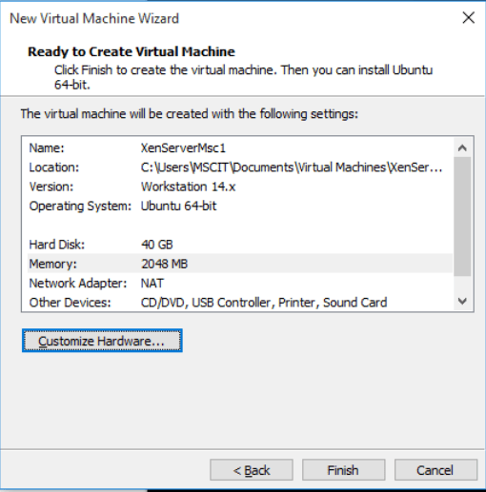

Now Power on newly created Virtual machine

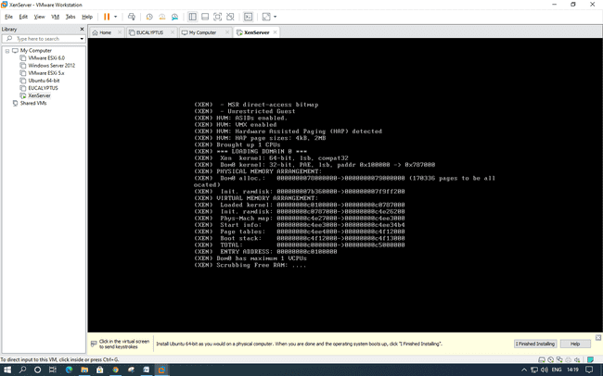

– Now select US and click on OK

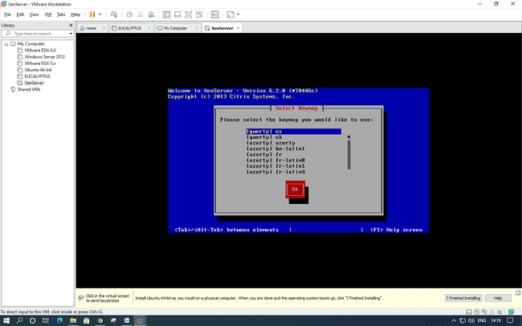

Click on OK as seen in below screenshot –

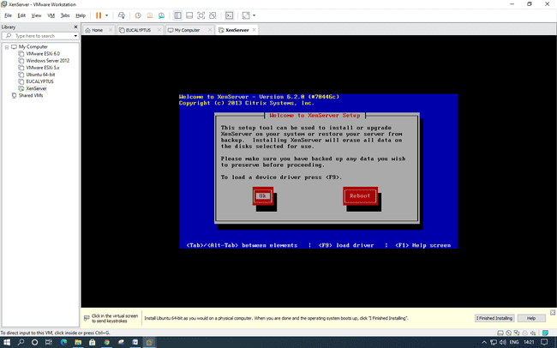

Click “Accept EULA”

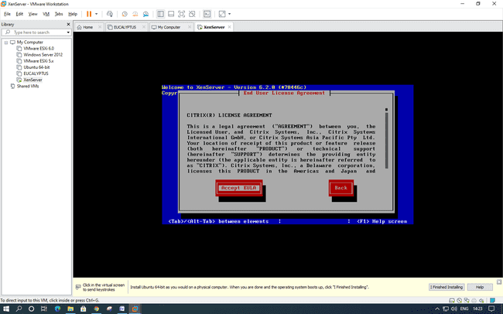

Click ok

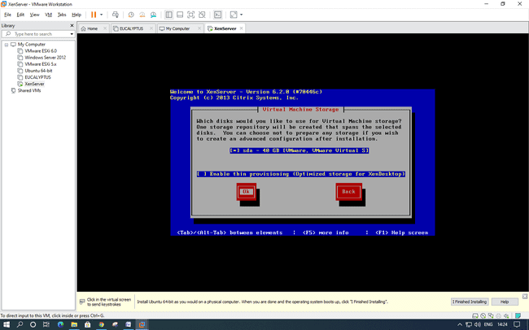

Select Local media and ok

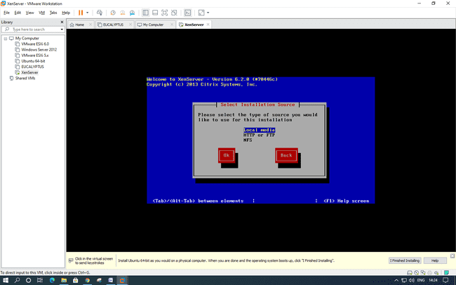

Click No

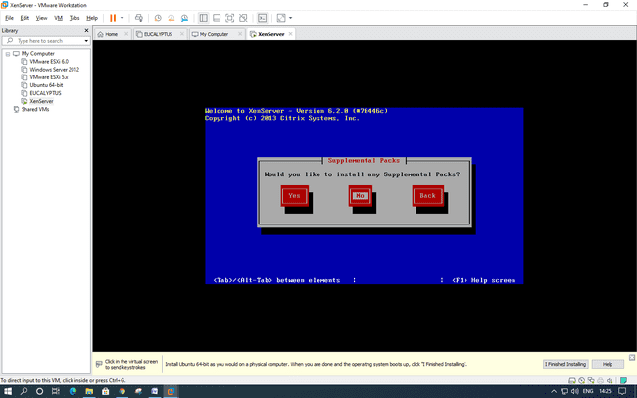

Here click varify installation

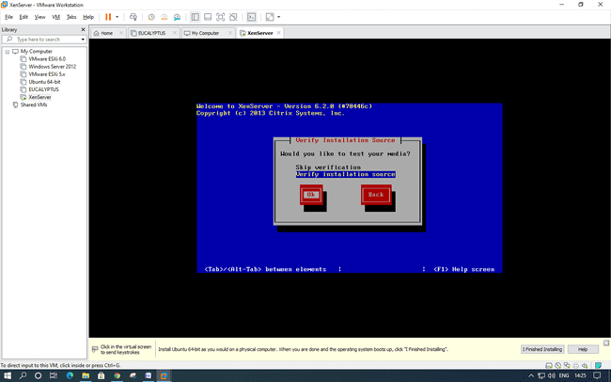

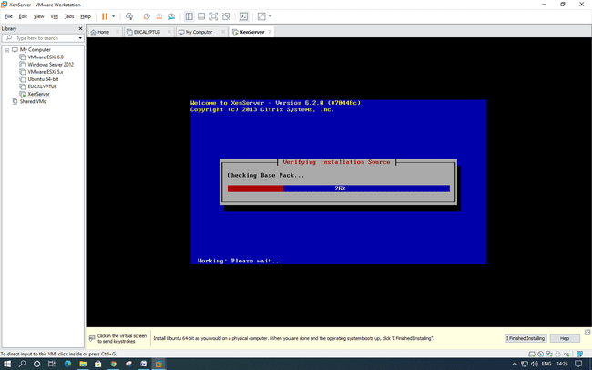

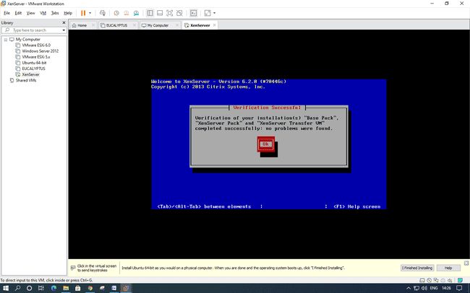

Insert password (Remember password entered) and click on Ok – Password:root123

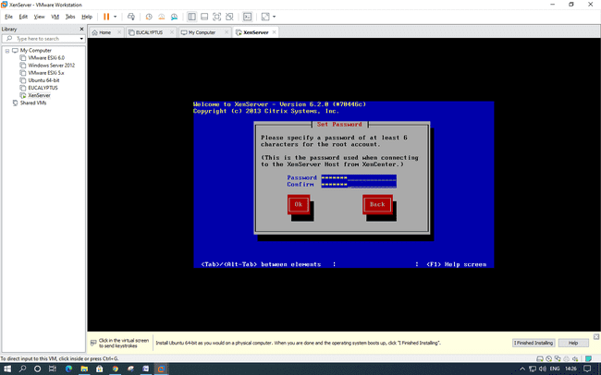

Select Automatically set via DHCP and click on OK

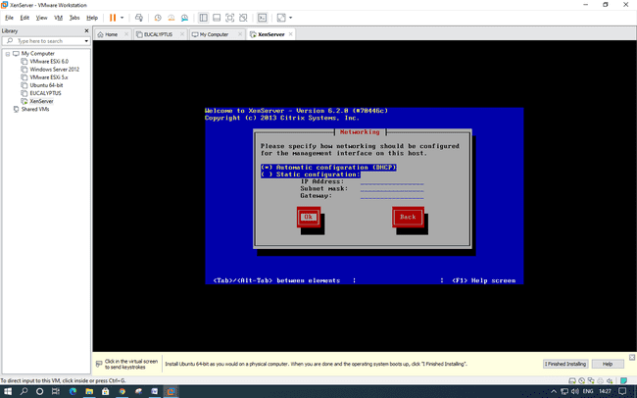

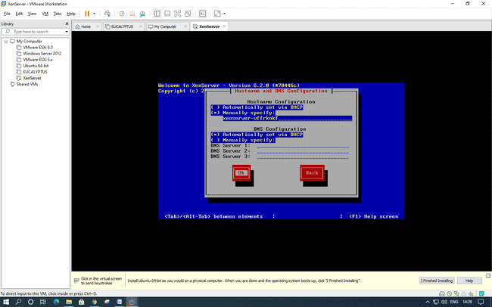

Select Asia and click on OK –

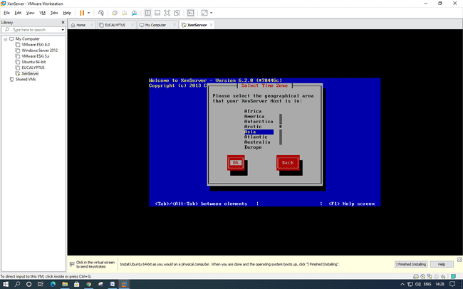

Select Calcutta

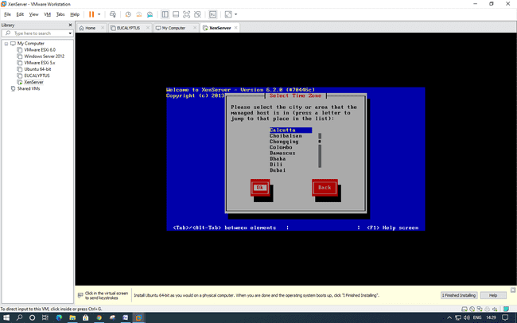

Select “Using NTP” and click on OK

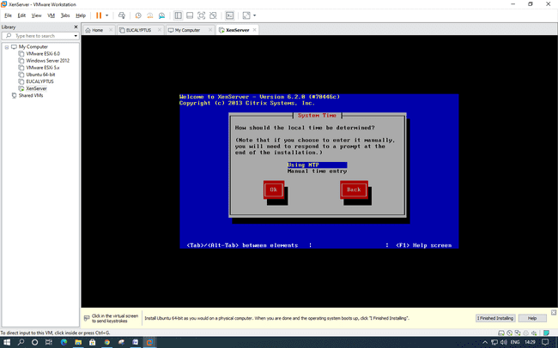

Click OK

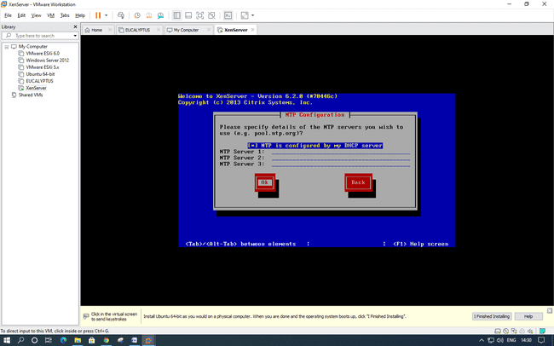

Click Install Xen server

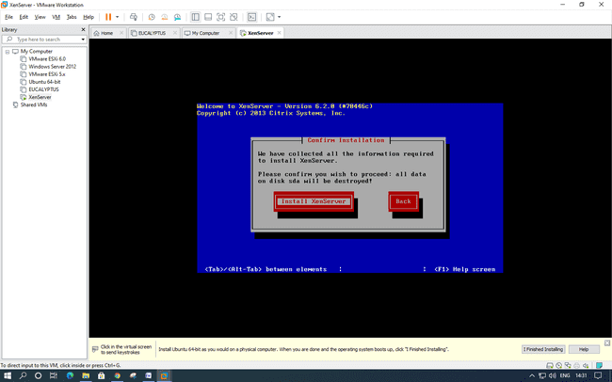

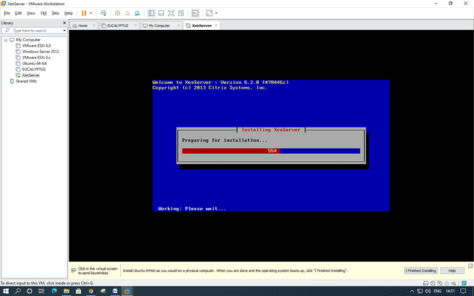

Click OK

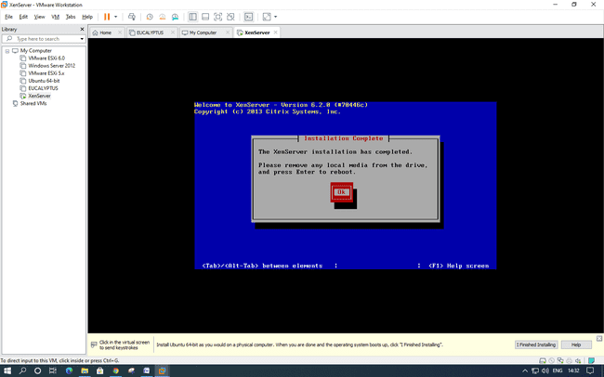

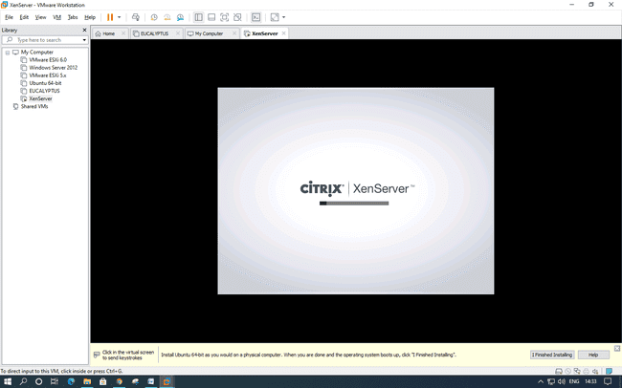

Note IP Addres – “ 192.168.107.137” ping it from command prompt

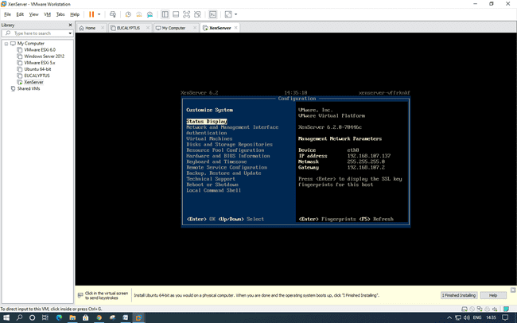

Now Install Citrix App if not installed –

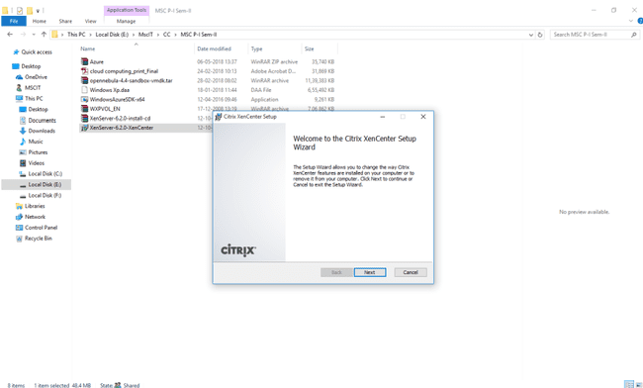

Now Open Citrix XenCenter – and Click and Add Server

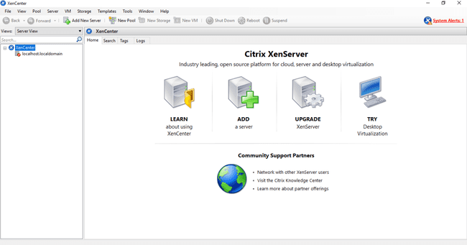

Fill IP address copied from Installation and User name as “root” and Password as “root123” which we had given during installation and Click on Add

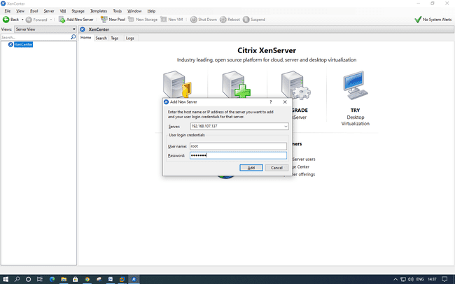

Now Click on New Storage –under Storage Tab.

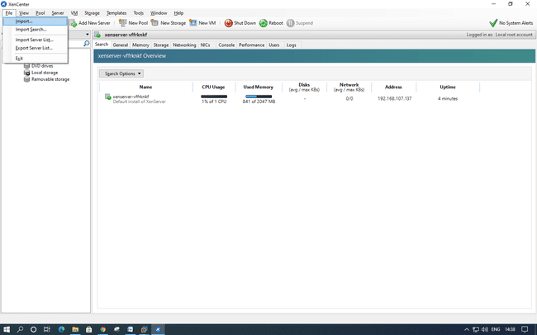

Select Window File Sharing (CIFS) and click on next –

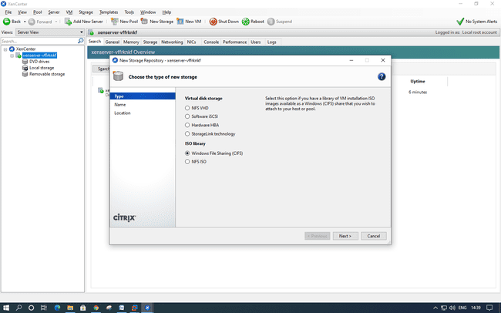

Uncheck Auto generate option Click on Next

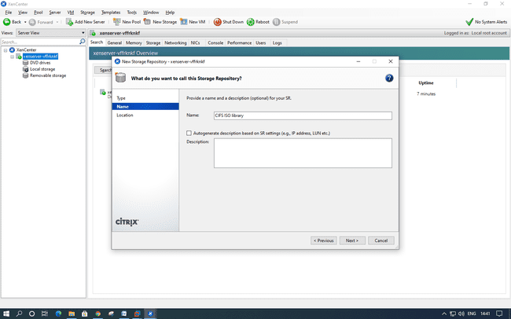

Provide the path of shared windows XP image and enter local pc credential ,, click on Finish

And enter Local PC Credentials

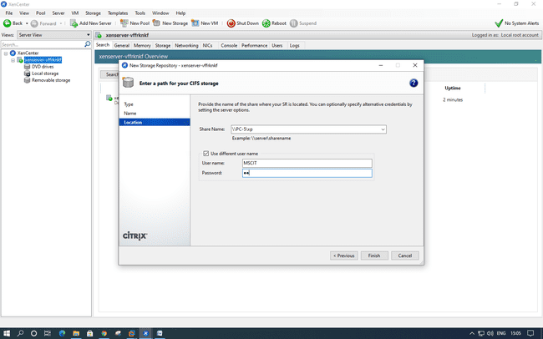

Click on New VM – and Windows XP SP3

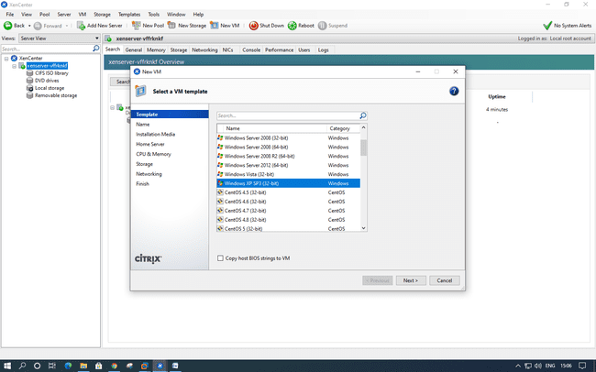

Select ISO file and click on next

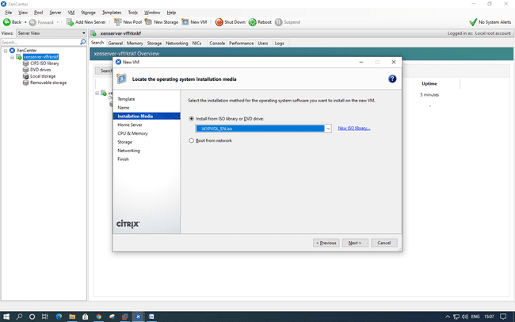

Select Place the VM on this server and click on next.

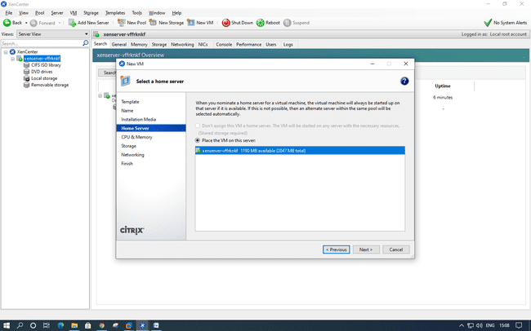

Next –

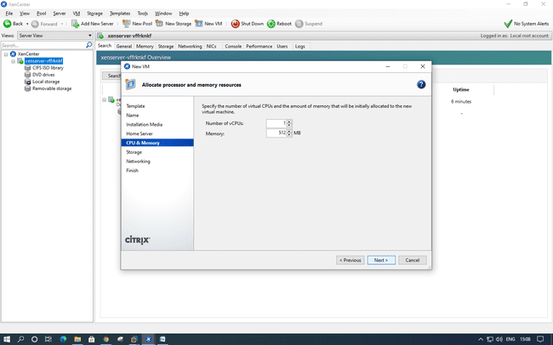

Select the Storage and click on Next.

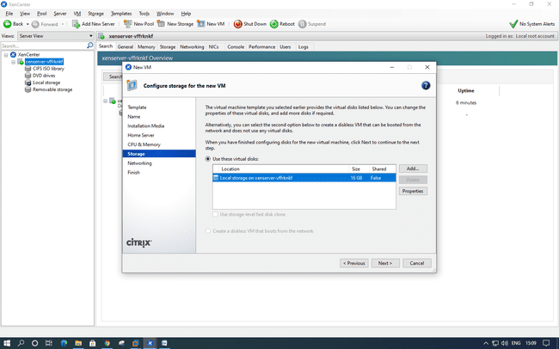

Next-

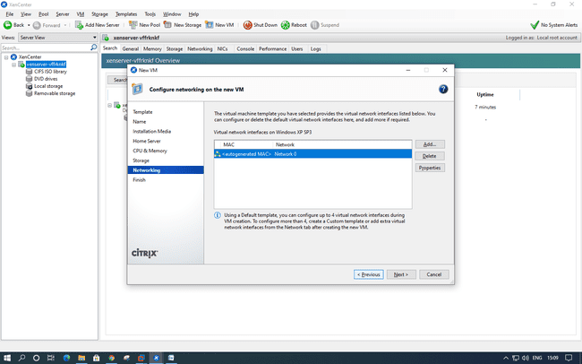

Uncheck – Start the new VM and click on create now

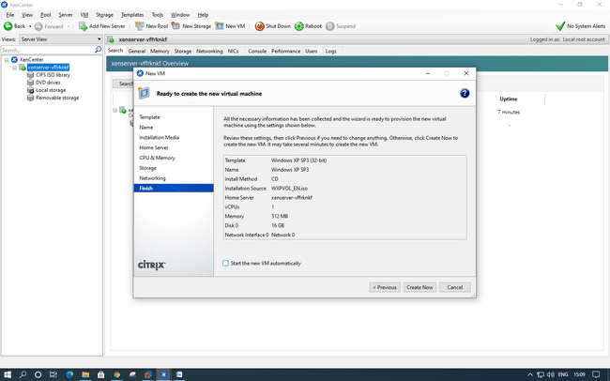

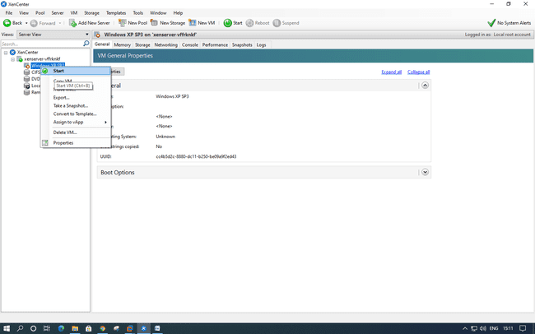

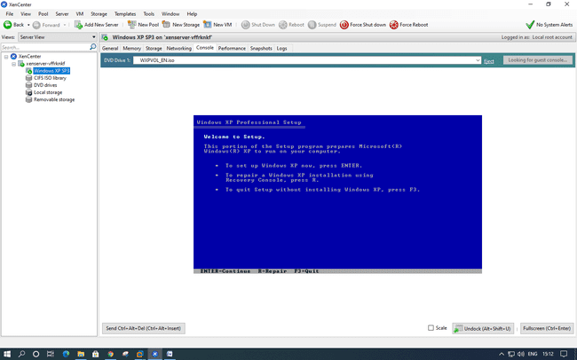

**PRACTICAL: 4**

**IMPLEMENT SEARCH ENGINE _ GOOGLE APP ENGINE (GAE)**

Open Eclipse and go to Help and select Eclipse Market place

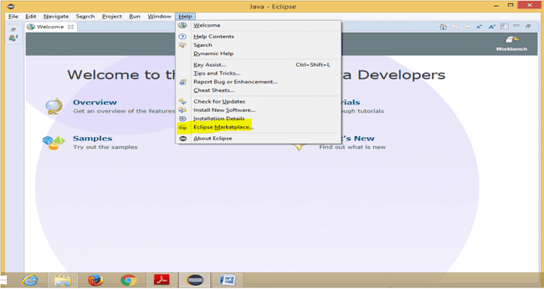

Search got Google Google Cloud and install it.

Restart Eclipse if asked.

Now Go to File🡪New🡪Others..

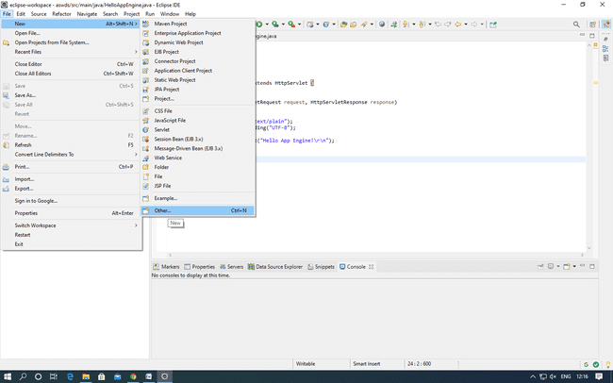

Select Google App Engine Standard Java Project

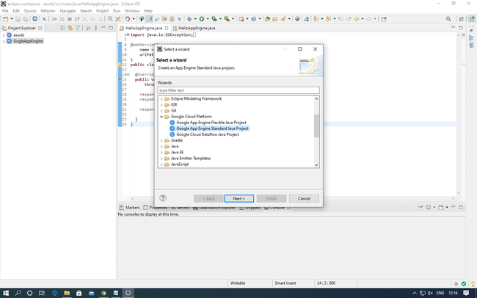

Give the name to your project and click Finish.

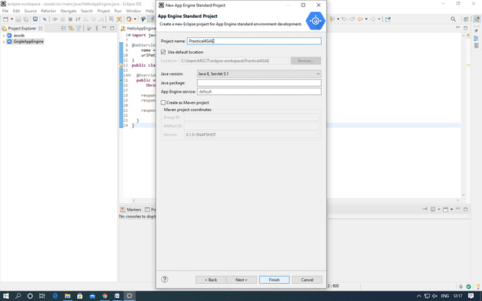

Type Code as per logic and right click to run as App Engine.

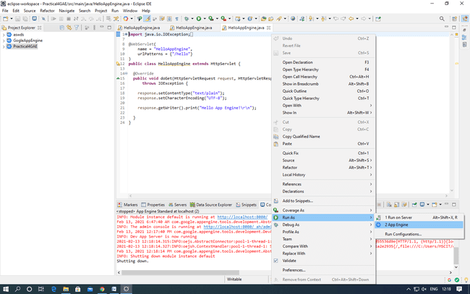

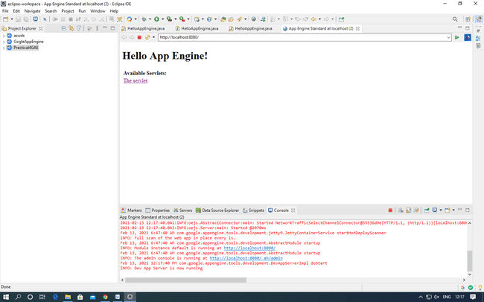

**PRACTICAL: 5**

**IMPLEMENT ESXi SERVER**

Steps: Open VMware Workstation – And select Create a New Virtual Machine

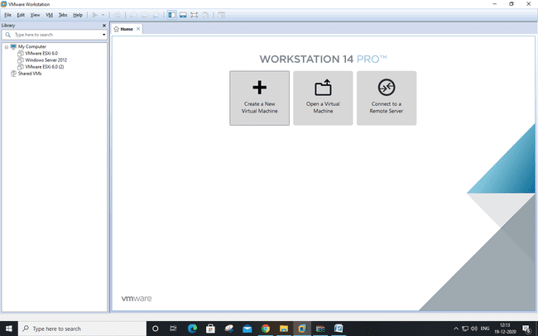

Select Typical and click Next

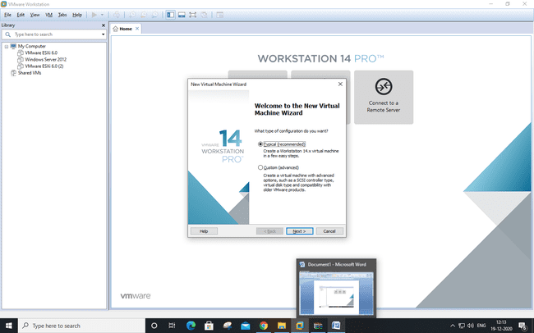

Select Installer disc_image file(ISO). Click Browse -ESXi-5.x-Custom.iso Iso File – For Example “D:\ccpraxrj\ESXi-5.x-Custom.iso” And click on next

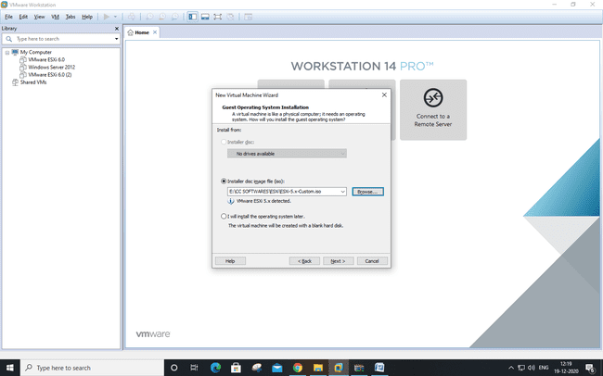

Give Virtual Machine Name and click on next.

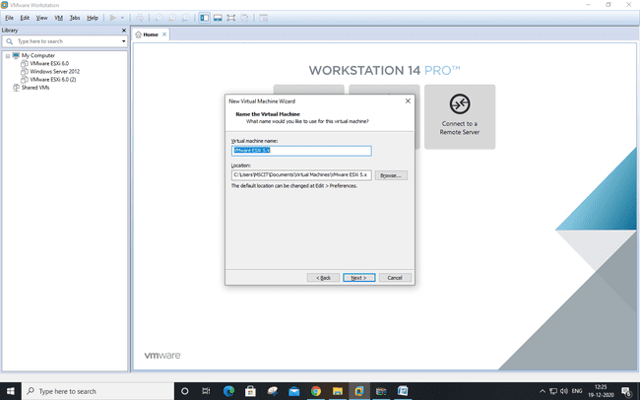

Change maximum disk size to 60 GB and check –Store virtual disk as single file

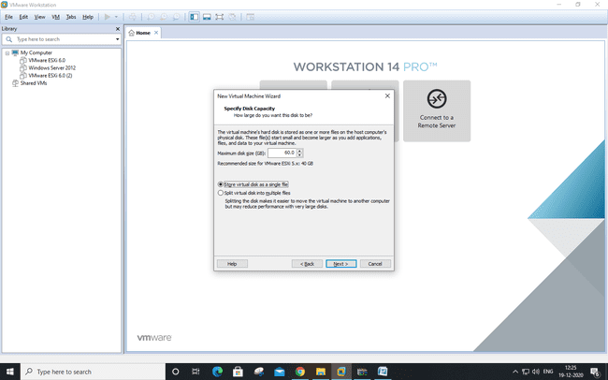

Click on Customize Hardware option

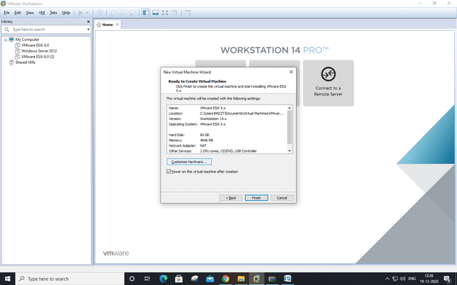

Change – Memory for this virtual machine to 4 GB and Click on Processor and select virtualize Intel VT and Click on Close.

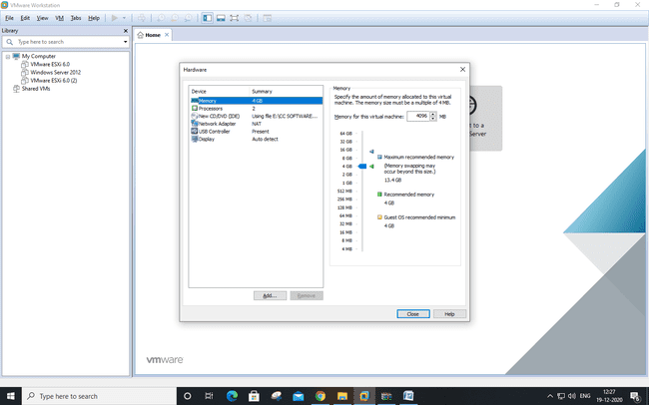

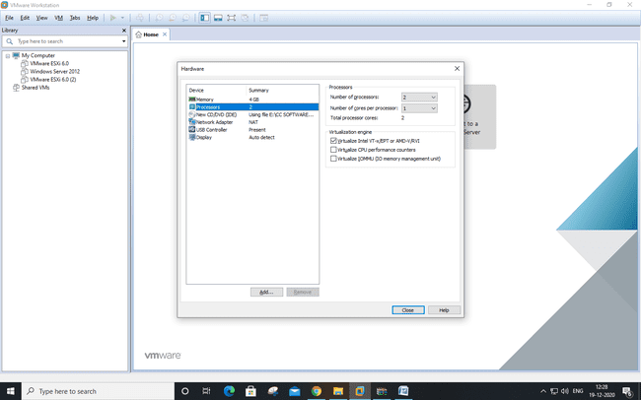

Now Power on newly created Virtual machine –

Click on install EXSi server

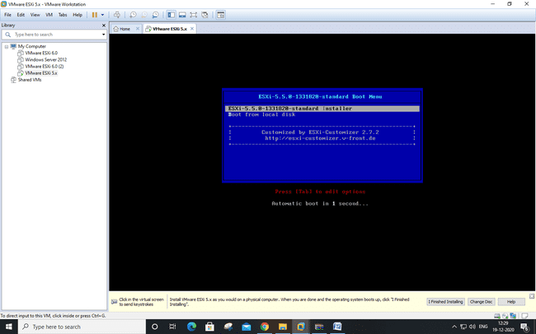

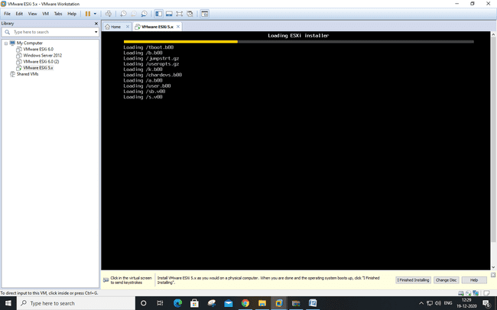

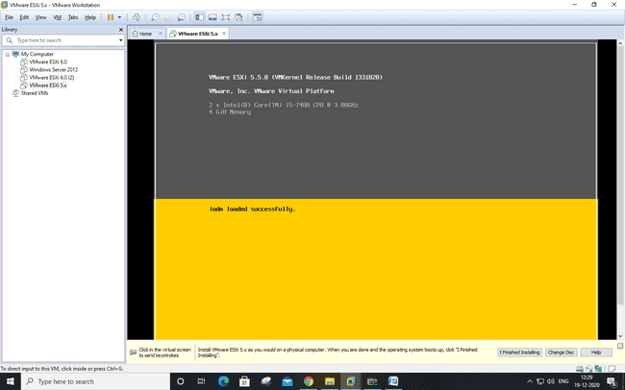

Press enter

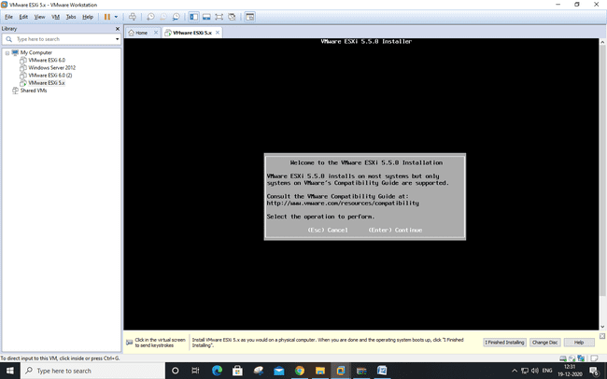

Select Accept and Continue.

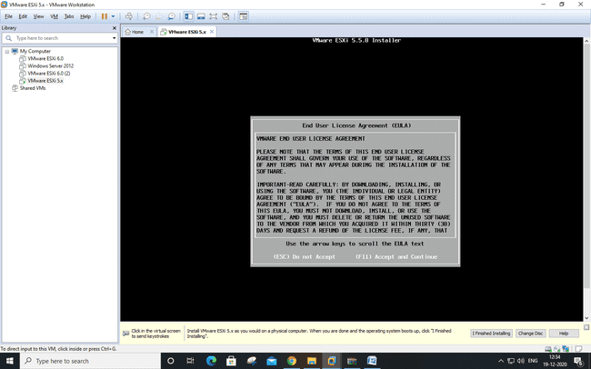

Click Continue

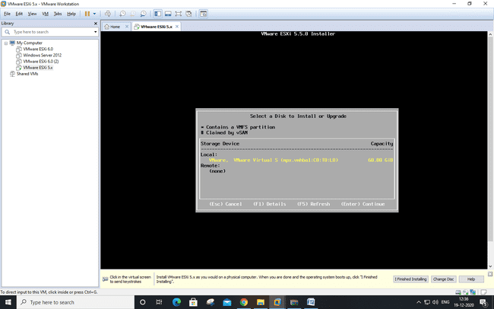

Select us default and click enter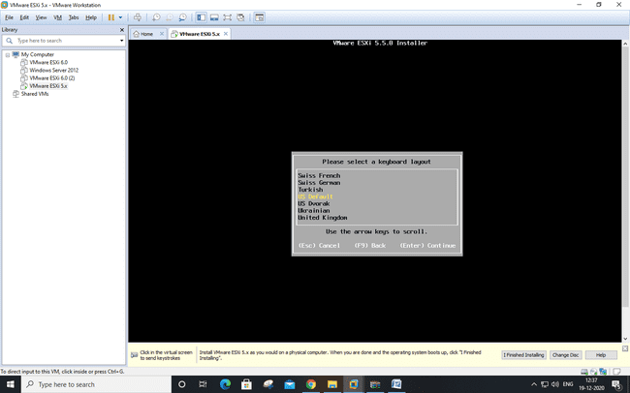

Create the root password and remember as you have to login VMWare Vsphere client using this password.

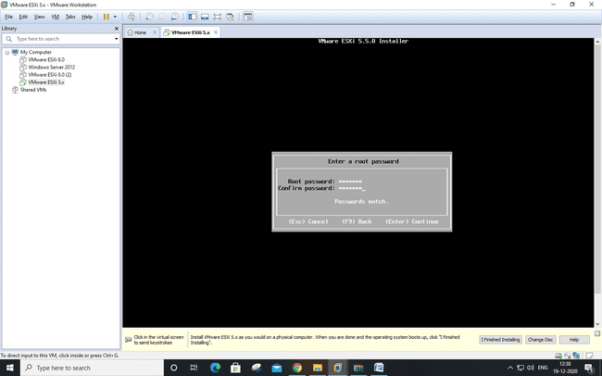

Click install

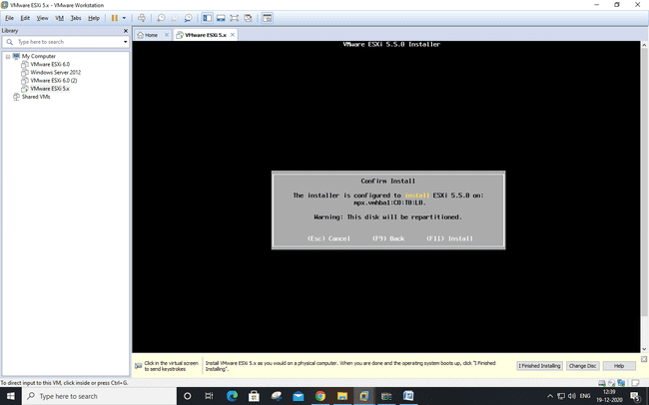

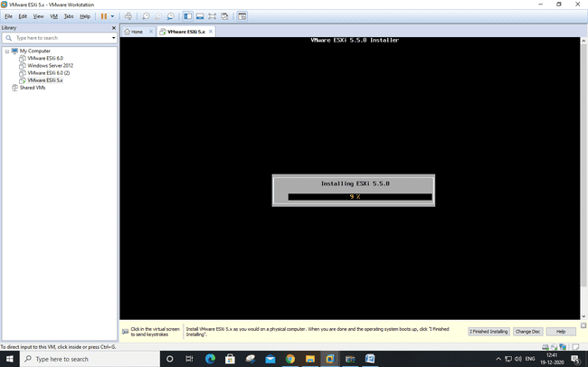

Press enter to reboot the system

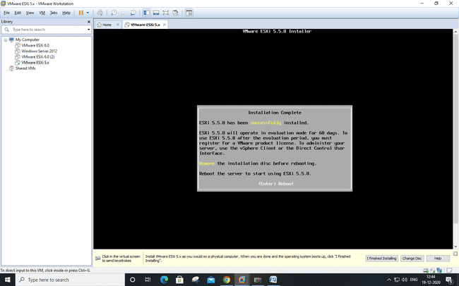

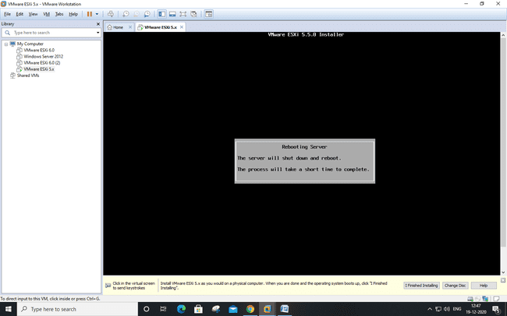

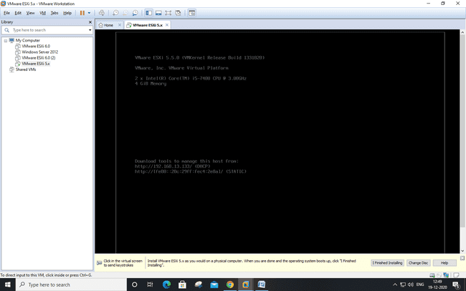

Browse the IP on Internet

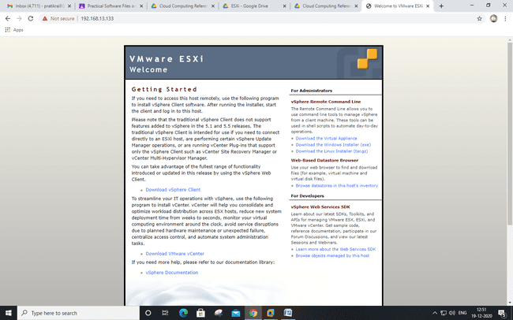

Installation of vSphere Client

Vsphere client is already installed, open it and enter the IP, Username and password

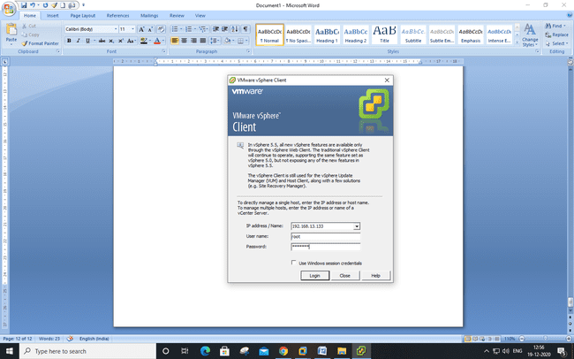

Select Summary tab.

In Storage section, Select on datastore1 and Right-click on Browse Datastore to add iso image of Windows XP in Datastore.

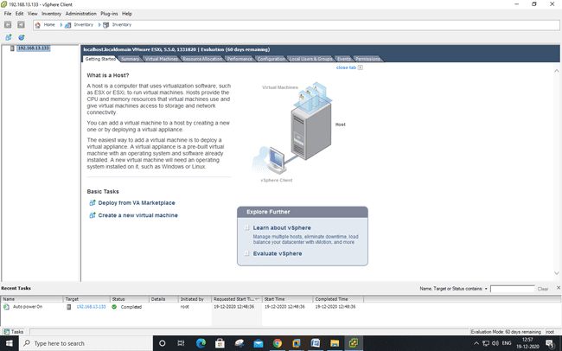

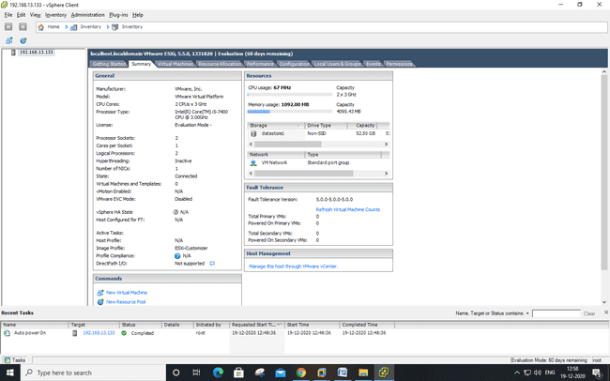

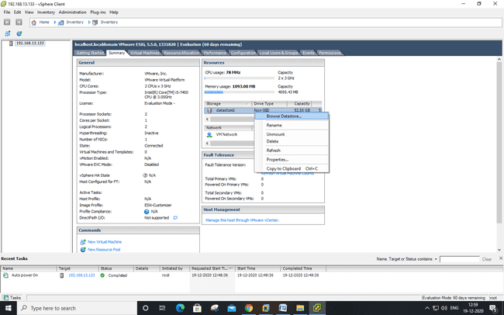

Click on Upload Icon and Select Upload File

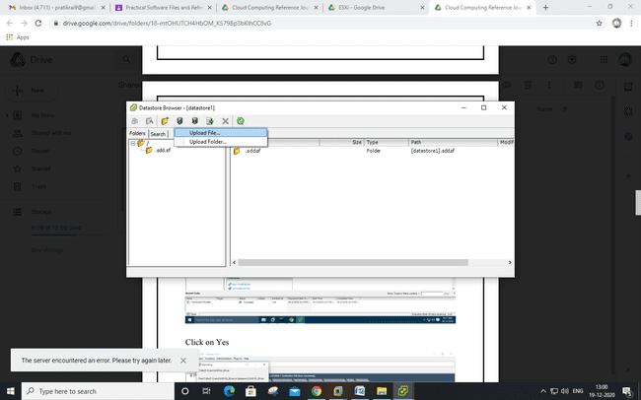

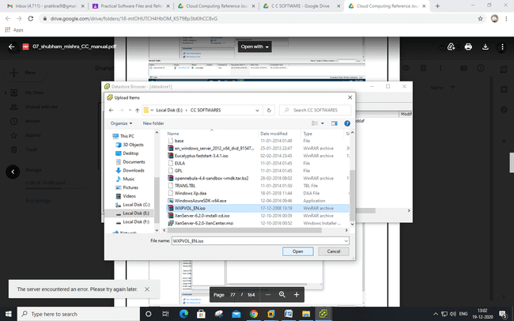

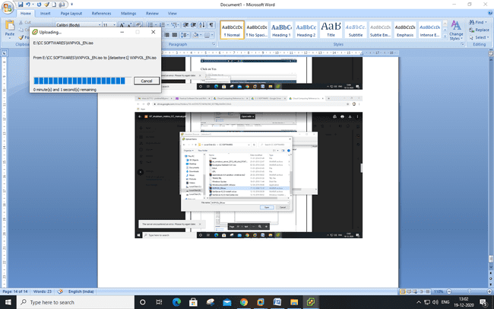

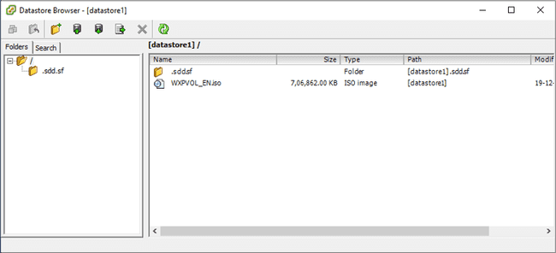

Go to Vsphere client and click on file-new- VM Configuration : Select Custom configuration.

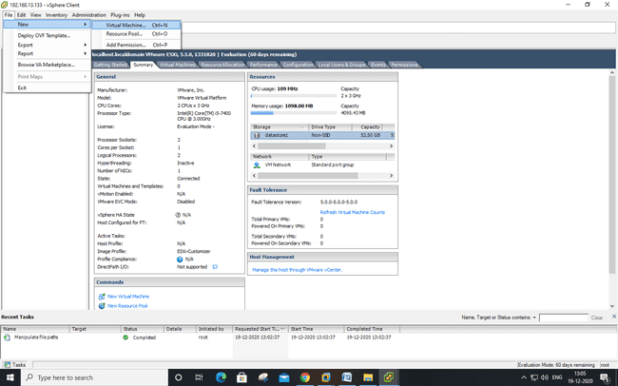

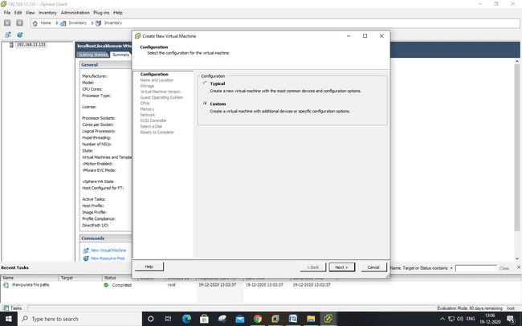

Name and Location: Give name to a Virtual Machine(Windows XP)

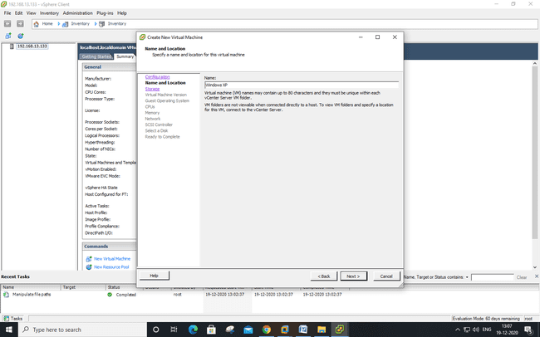

Storage:Select datastore1 and click Next

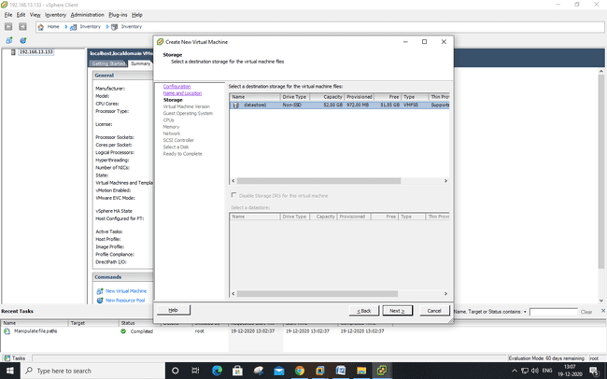

Virtual Machine version : Select Virtual Machine version 8

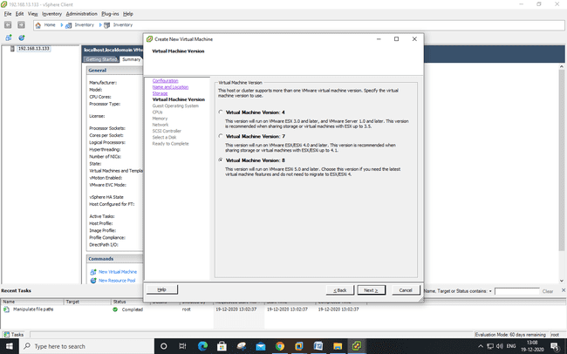

Guest Operating System: Windows Version: Microsoft windows XP Professional (32-bit)

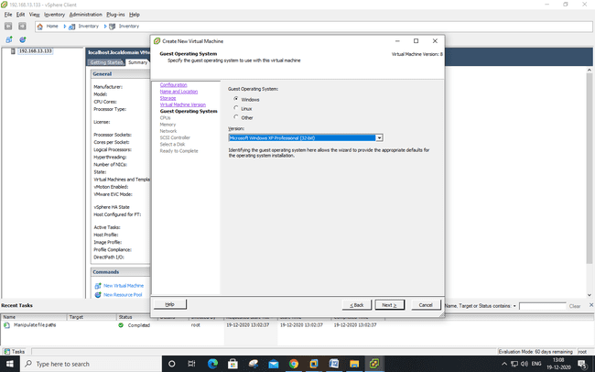

CPUs : Number of virtual sockets : 1 Number of cores per virtual socket: 1

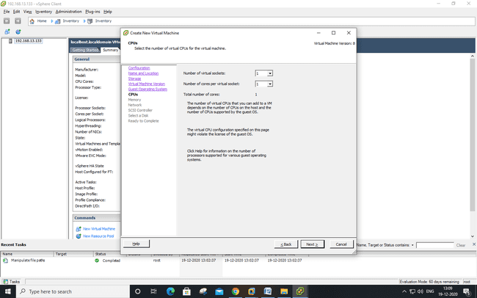

Memory: Memory Size : 1 GB

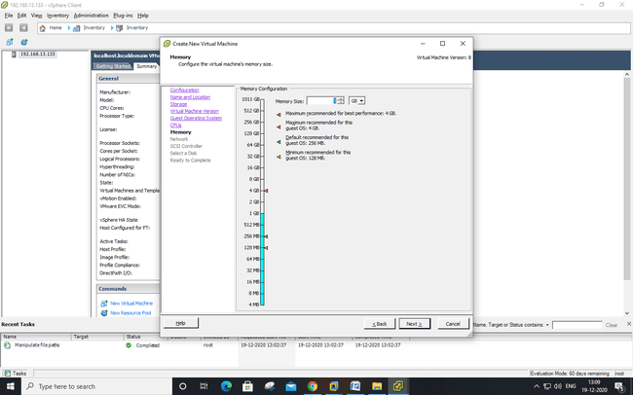

Network: Number of NICs : 1

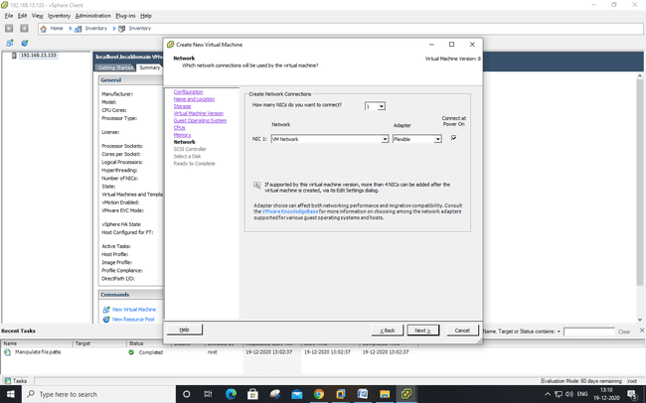

SCSI Controller : VMware Paravirtual

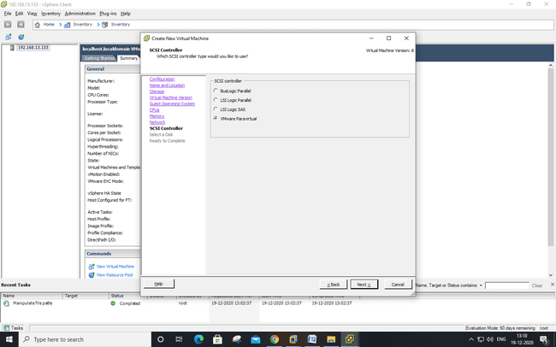

Select a Disk: create new virtual disk.

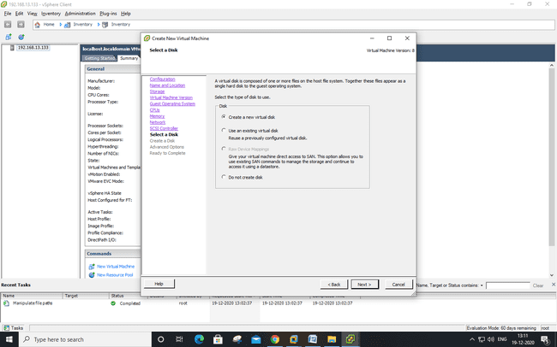

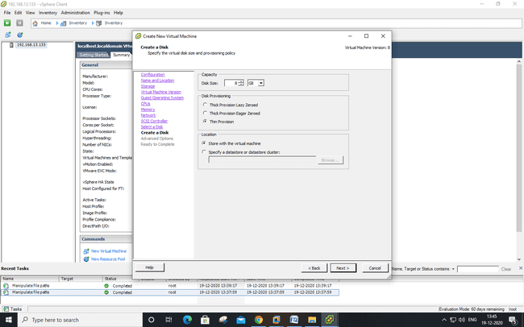

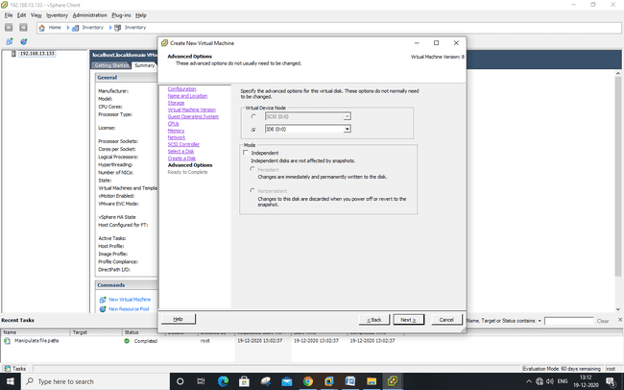

Click edit

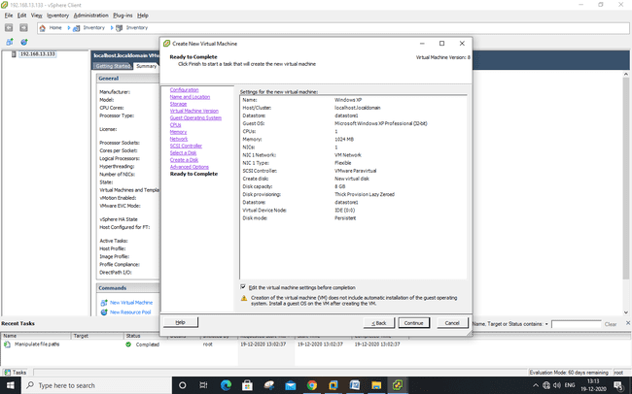

Click on Datastore ISO File and Browse the datastore you added (WXPVOL_EN.iso)

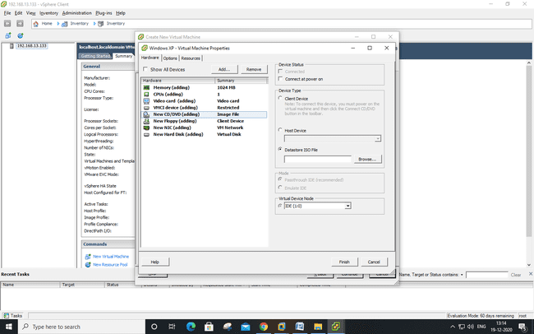

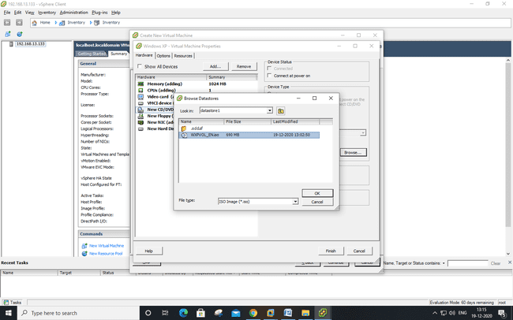

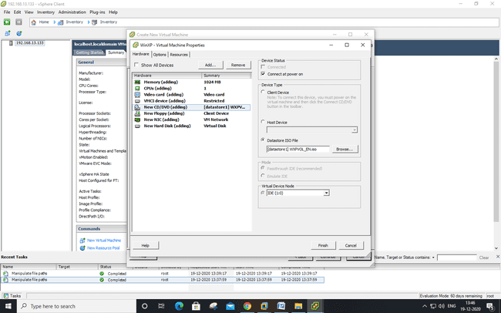

Click on Finish.

Right Click on Windows XP >> Power >> Power On

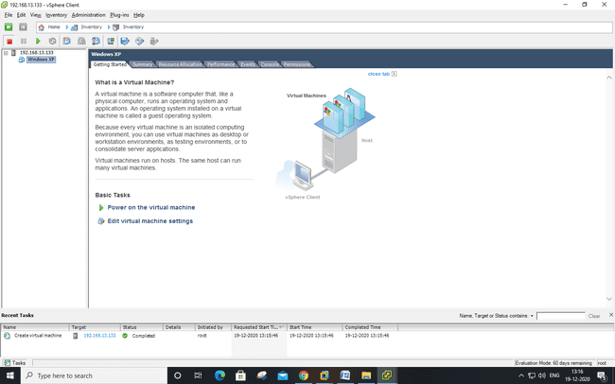

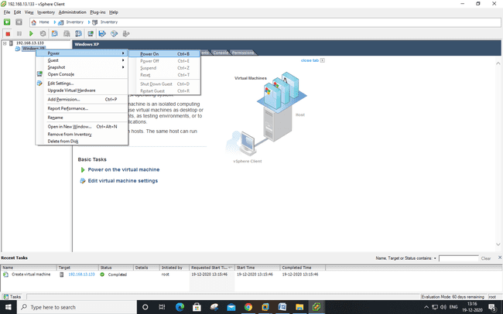

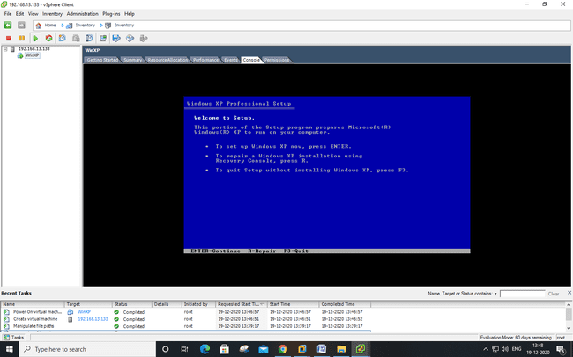

**PRACTICAL: 6**

**NATIVE VIRTUALIZATION USING Hyper-V**

First we have to uninstall vmware software if already installed on computer because the VMware Workstation installer does not support running on a Hyper-V virtual machine.

After uninstalling VMware, we can proceed to next step - go to control panel and click on uninstall a program

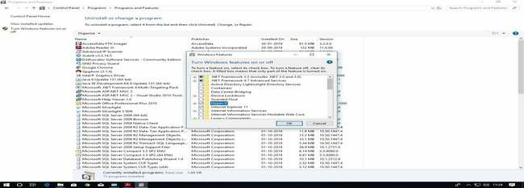

After Restart **Search for hyper-v manager in search box and click on that**

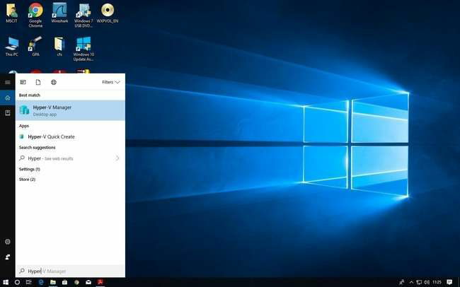

**for creating virtual machine, first we have to create virtual switch**

click on virtual switch manager option

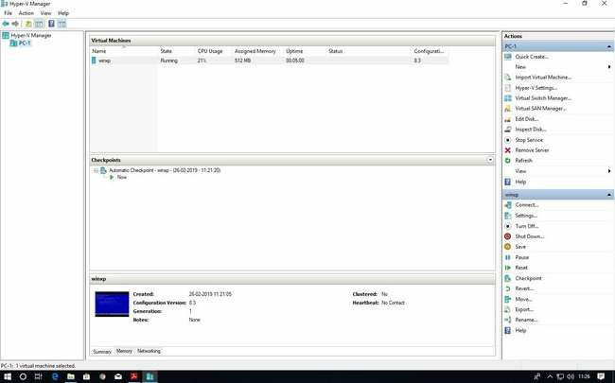

Select External as a connection type and then click on create virtual switch

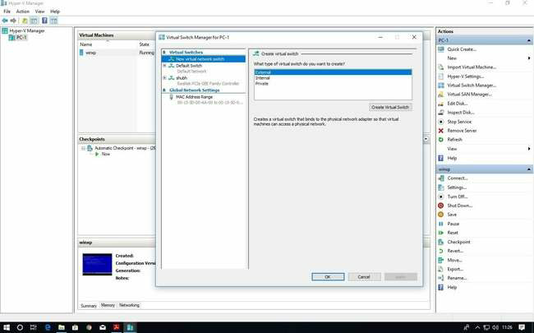Give name to your virtual switch then click on apply button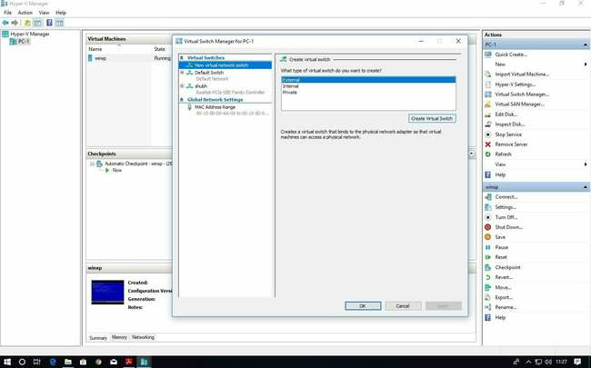

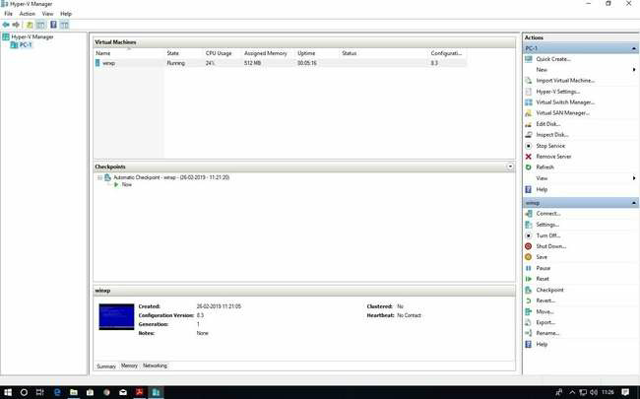  
  
  
  
  
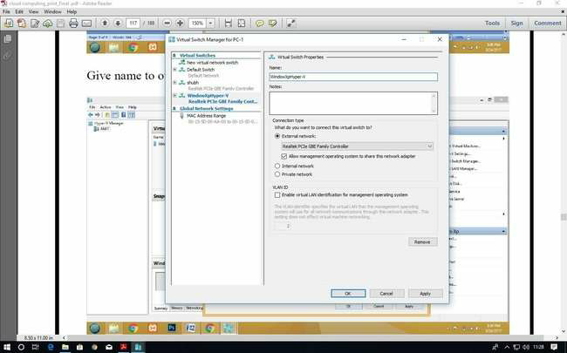

after click on Apply button it will show warning about our connection click on yes

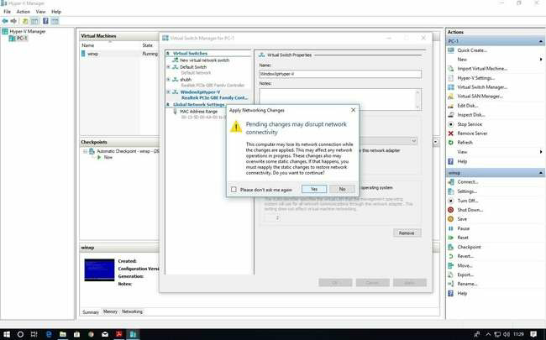

Now right click on server and select new virtual machine

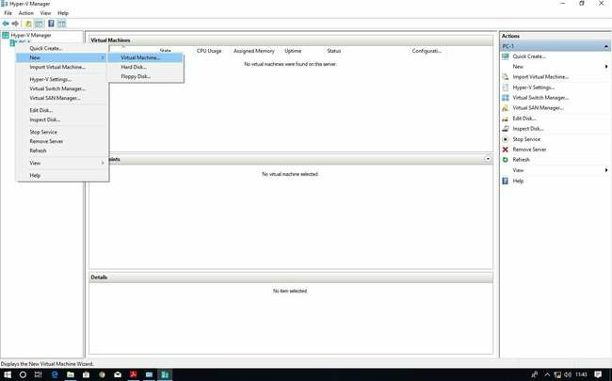

click on next button

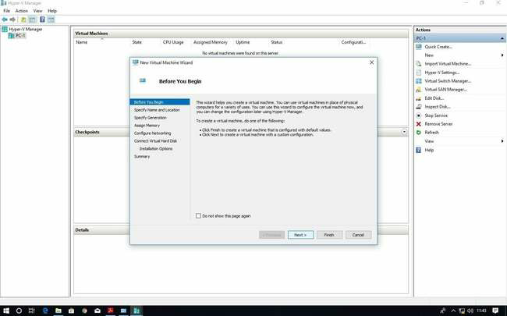  
  
  
Provide name to virtual machine then click on Next button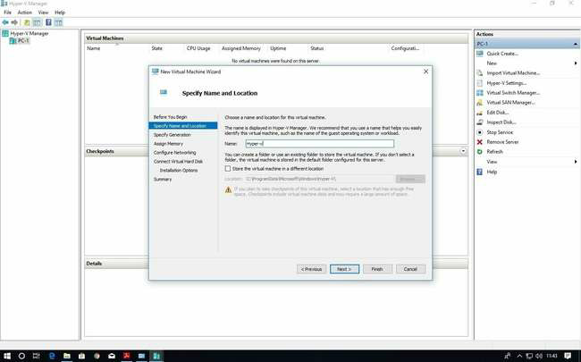

Specify generation : generation 1

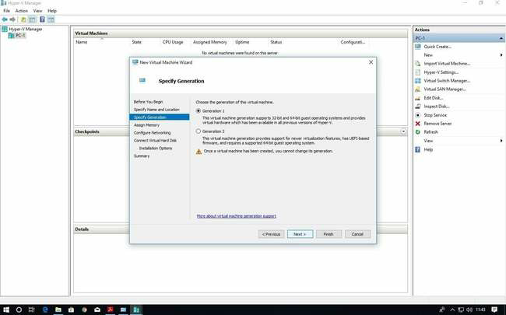  
  
  
tick on use **dynamic memory for this virtual machine**

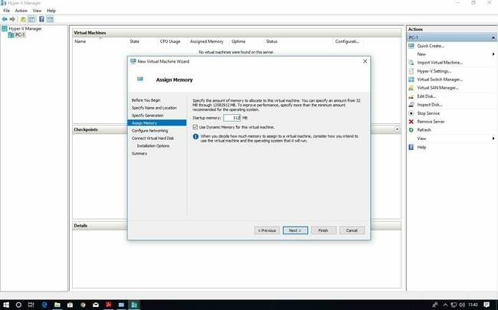

Select switch which we created earlier for our virtual machine from drop-down list and then click on next

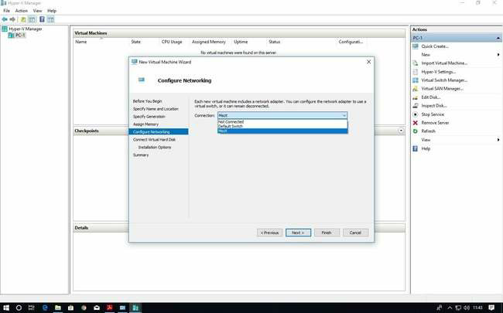

Description of virtual machine and location where it will store virtual machine related files and size require for this machine click on next

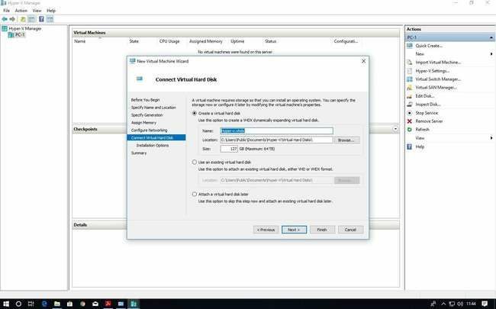

New virtual machine wizard panel will appear, where we will choose operating system which we want to install on virtual machine

select install an operating system from boot CD/DVD-ROM and then select Image file(.iso) and browse your OS iso file then click on next button

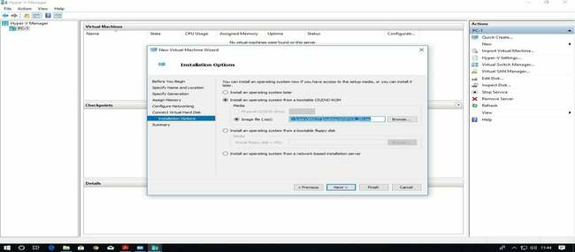

Summary report will be generated about virtual machine then click on Finish  button

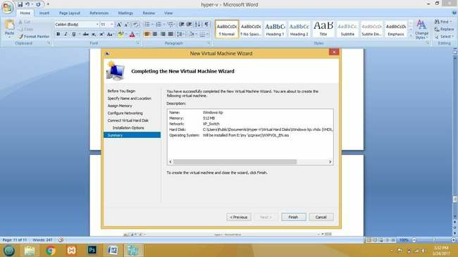

In virtual machine panel your virtual machine will appear which has off state

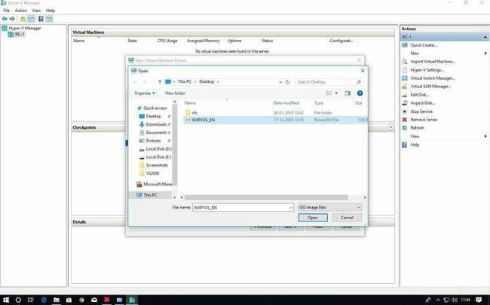

Click finish

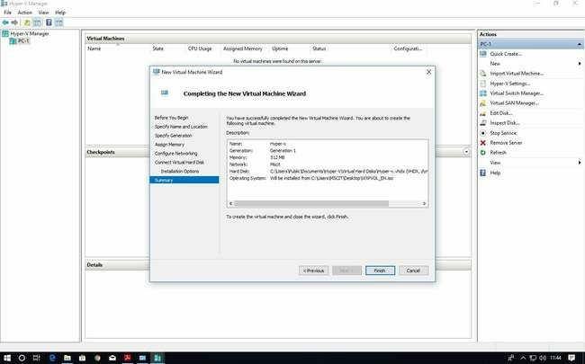

Right click on virtual machine and click on connect option

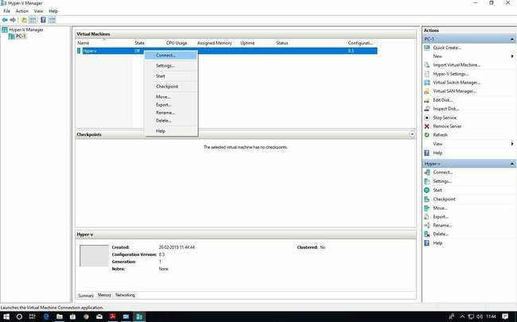

Now turn on virtual machine

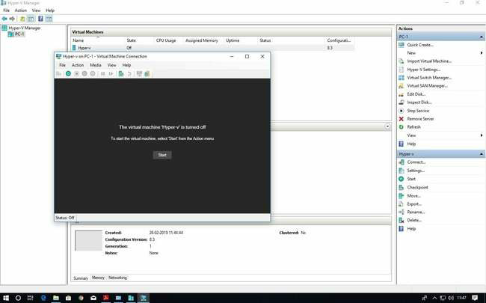

Virtual machine will start with below screen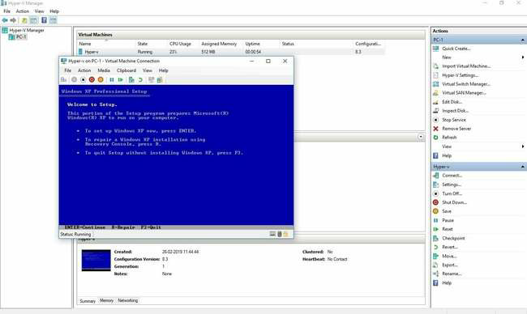

**PRACTICAL: 7**

**IMPLEMENT OPENNEBULA**

To perform Open Nebula, EXSI VM should be kept on.

Start vSphere Client.

1. Enter Static IP address
2. Enter Username and Password. Click Login.

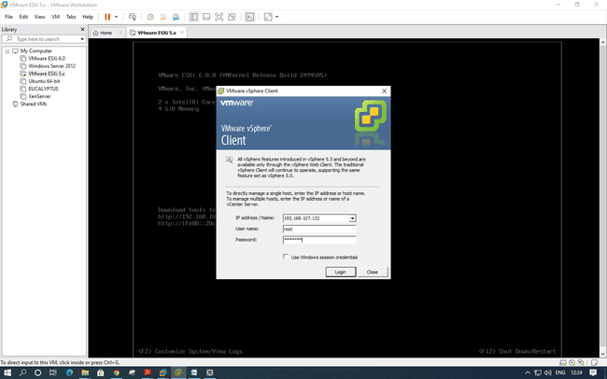

Go to Configuration tab select storage and right click on data store1 and select Browse Datastore.

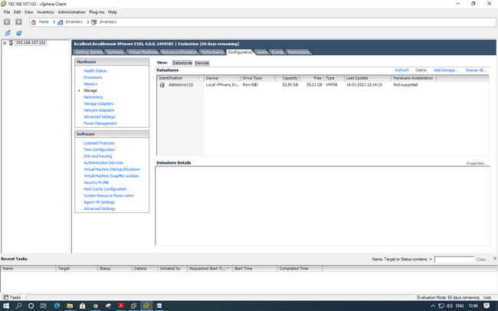

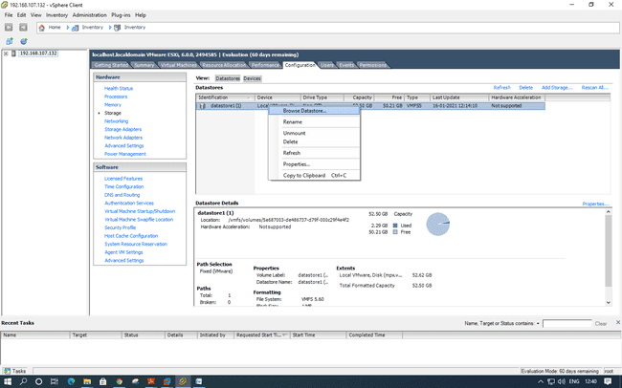

Go in this particular folder opennebula-4.4-sandbox-vmdk and select disk-flat

file.

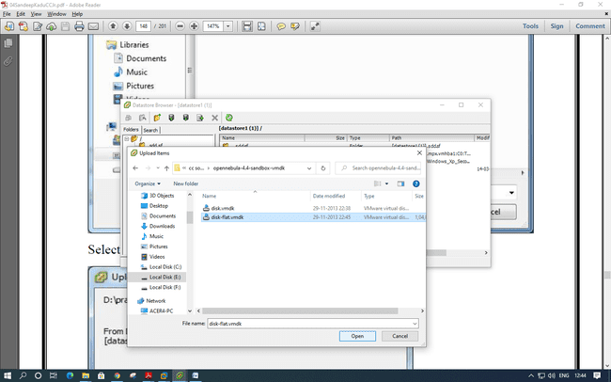

Right Click on the server IP and click on new virtual machine, Select Custom and click on next

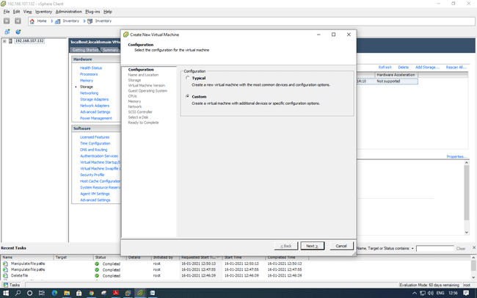

Name the VM as Opennebula-sandbox and click on next.

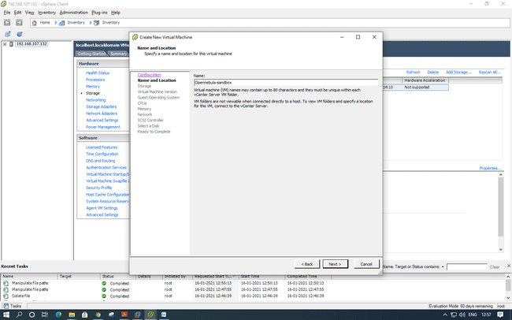

Select the datastore and click on Next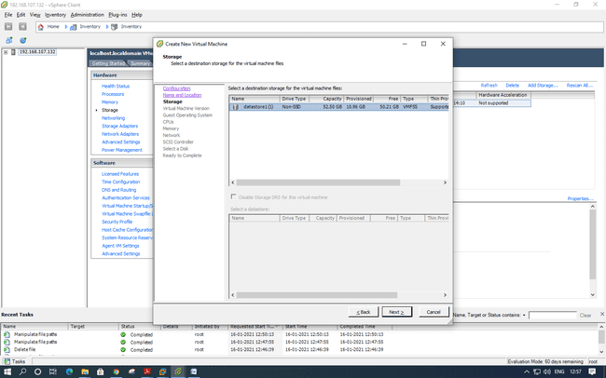

Select Virtual Machine version :8 and click on Next

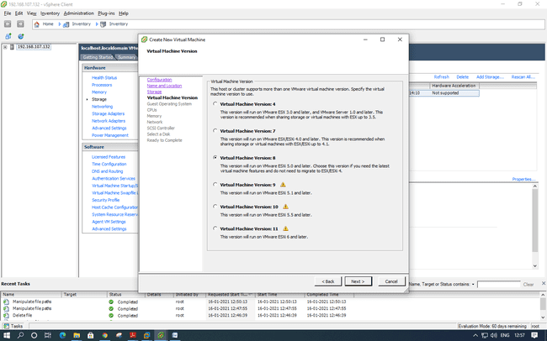

Select Linux as Guest OS and version as CentOS 4/5/6/7 (64-bit)

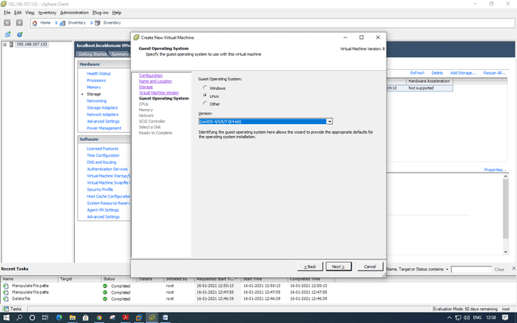

CPUs: Accept the default and click on Next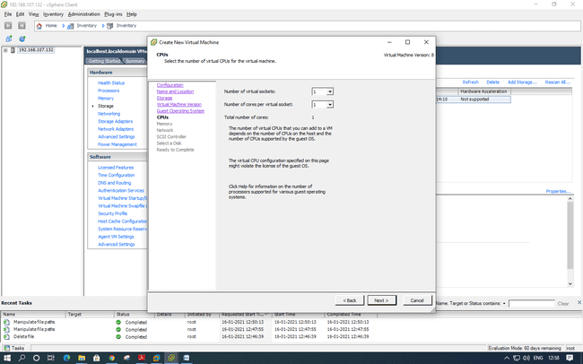

Select memory as 1 GB and click next

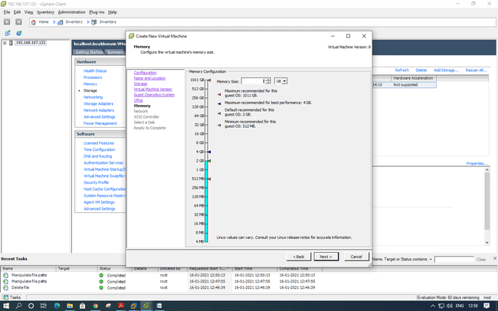

Select it as default and click next

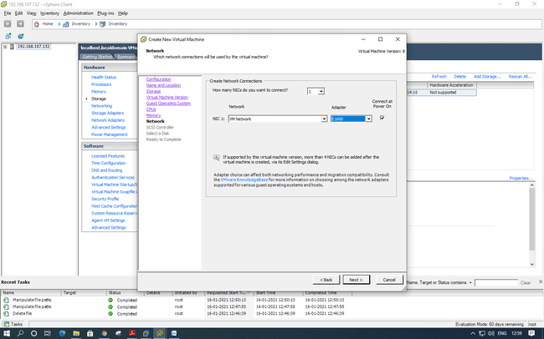

In the SCSI controller select as VMware Paravirtual and click next.

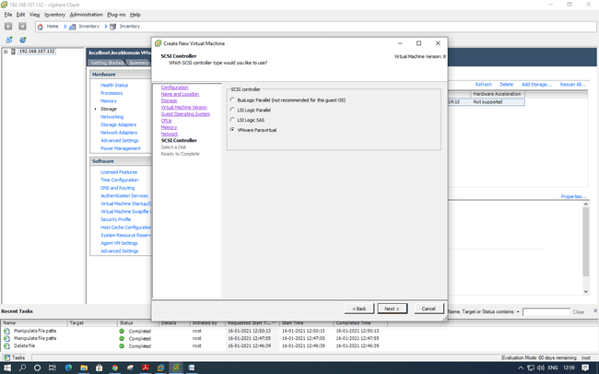

Select disk --> use an existing virtual disk and click next.

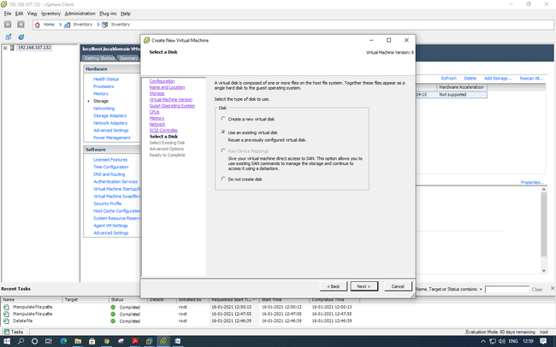

Click on browse and select data store1

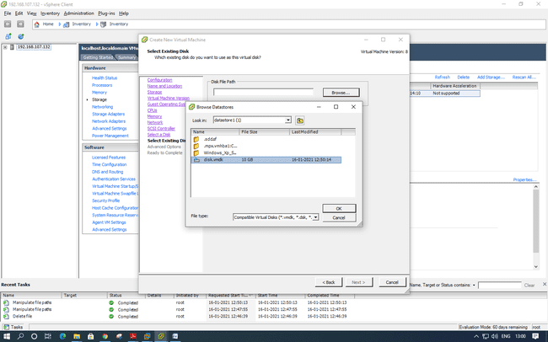

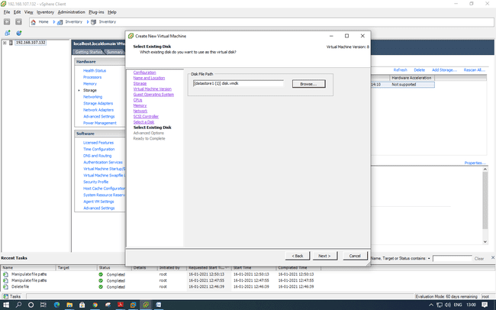

Click on Next and Finish.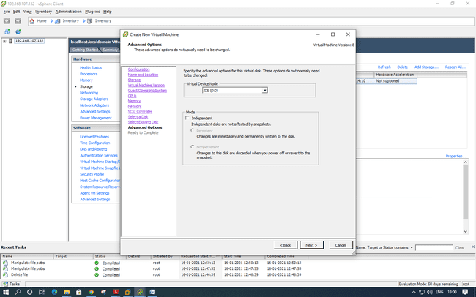

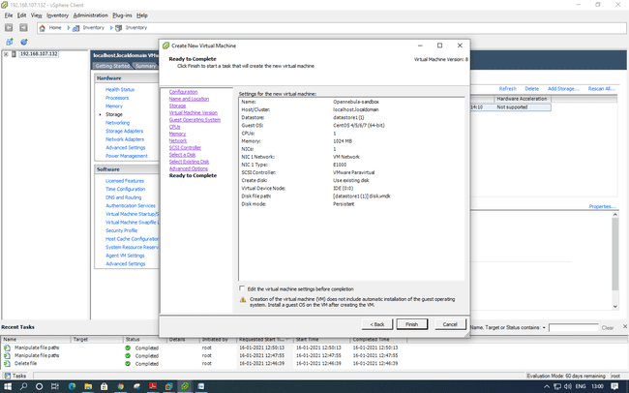

Power on the virtual machine and click on console tab

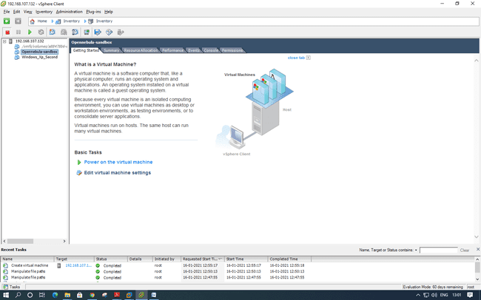

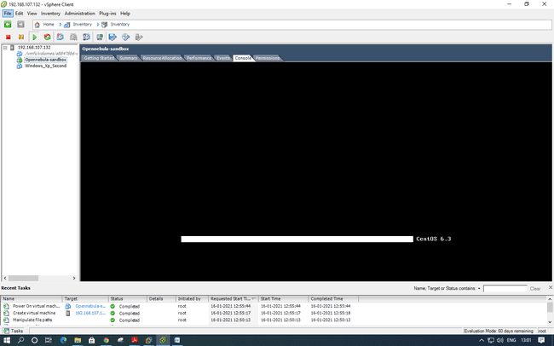

Login: root

Password: opennebula

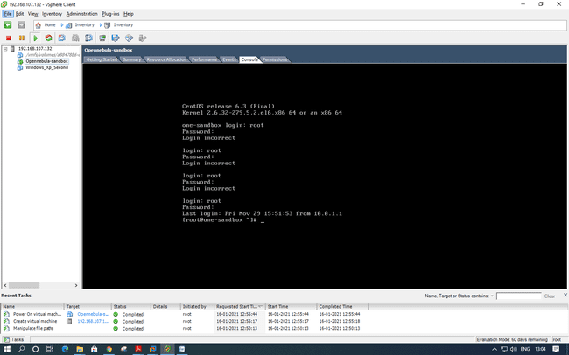

Type ifconfig eth0 command to check ip address of linux centos machine

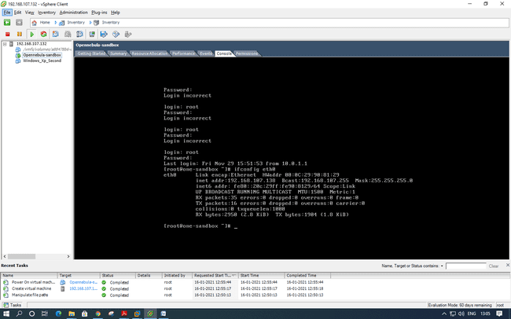

Since IP address of open nebula is 192.168.107.138

Try to ping from command prompt and on host OS

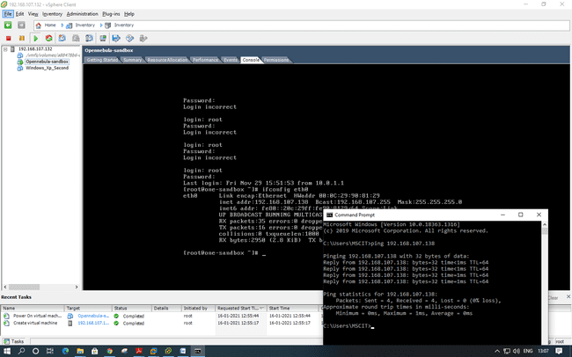

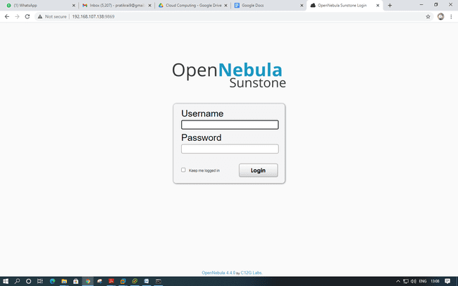

Type username : oneadmin

Password : opennebula

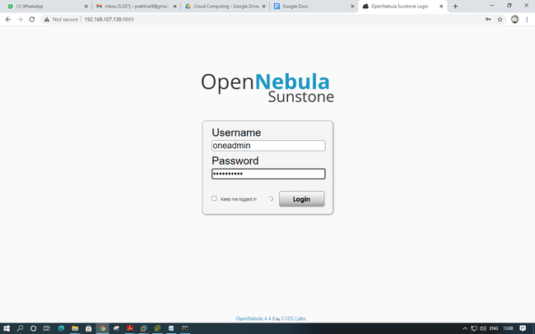

Dashboard of Open nebula.

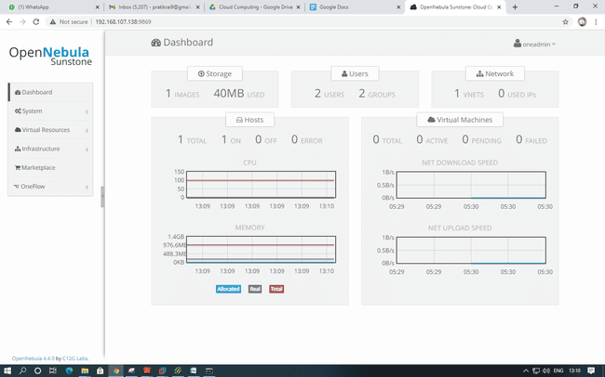

Create datastore -- > click on create

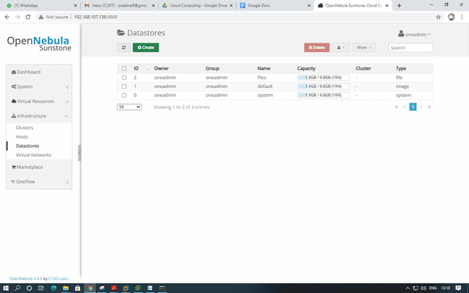

Give the name to Datastore and click create.

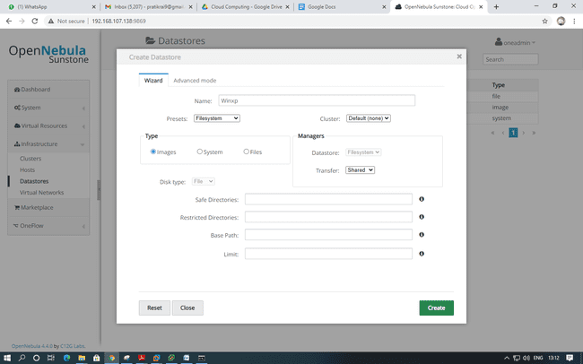

Provide Full rights to datastore.

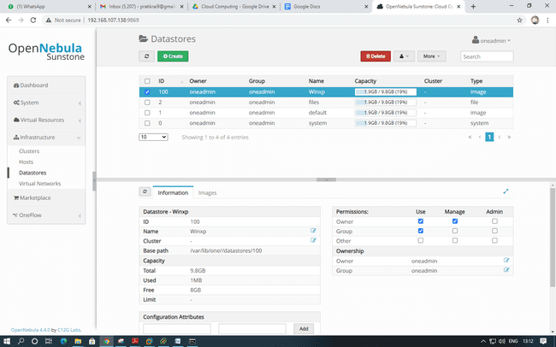

Create Virtual network 🡪 Expand Infrastructure Tab from menu and select Virtual Network and click on create

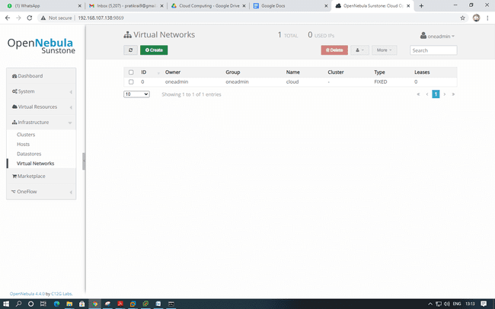

Provide name to virtual network and click on fixed network and provied ip address in range "192.168.1.100" to "192.168.1.106" and also provide Bridge name :"br0" and give full rights to Virtual network.

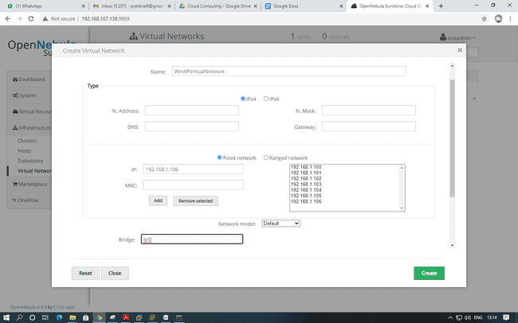

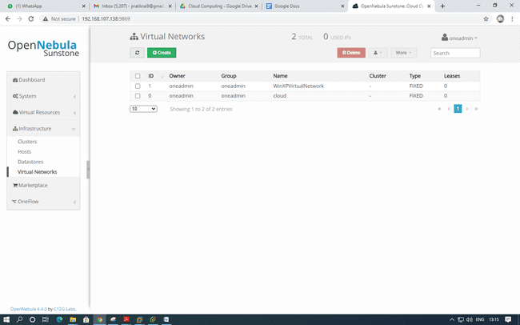

Create a new user with below details:

Username : opennebula

Password : opennebula

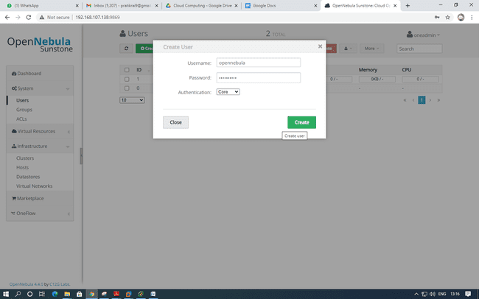

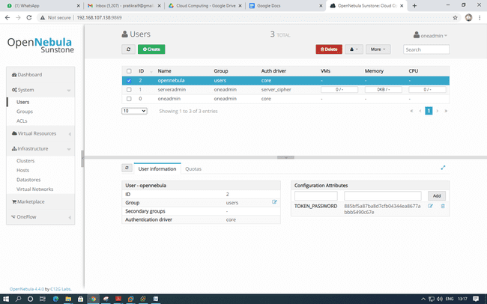

Login Using newly created user

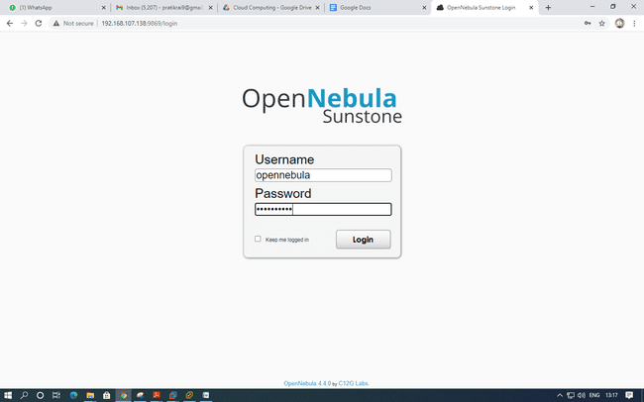

Click on virtual resources and select images

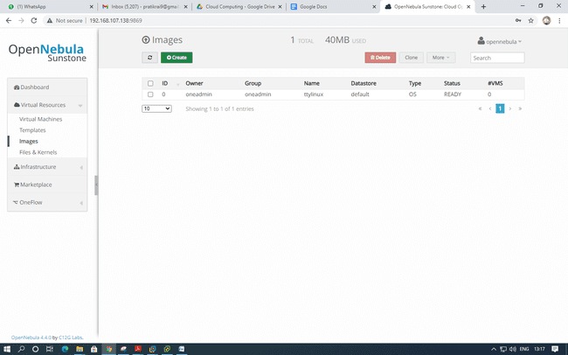

Create a new Image and name the image and provide full access

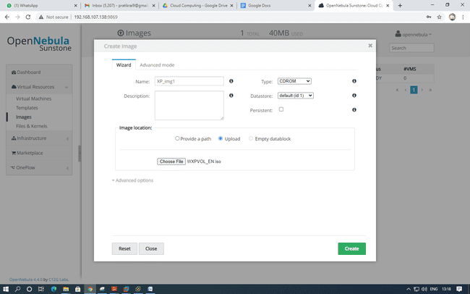

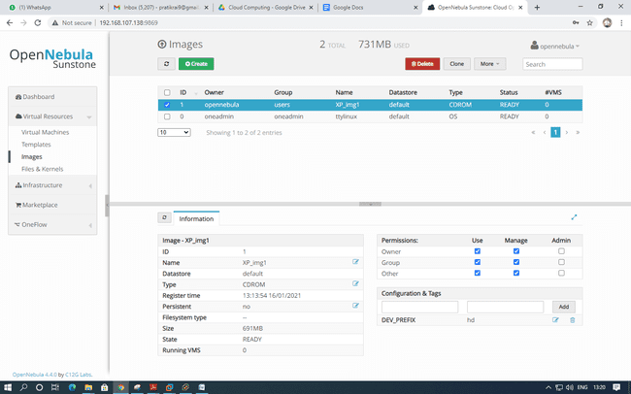

Click on templates under Virtual Machine and create a template by giving a name to template.

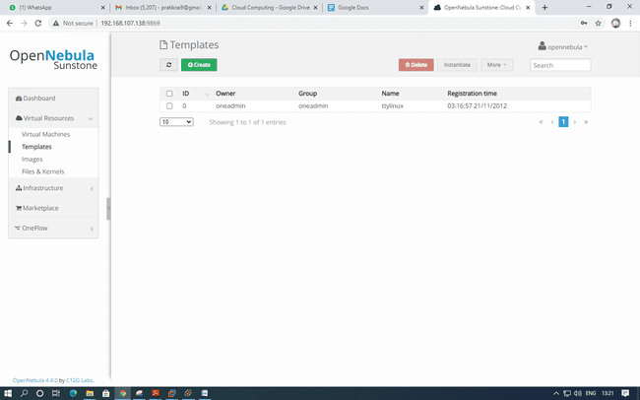

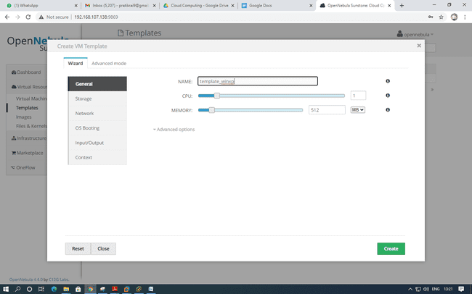

Select the storage that was created.

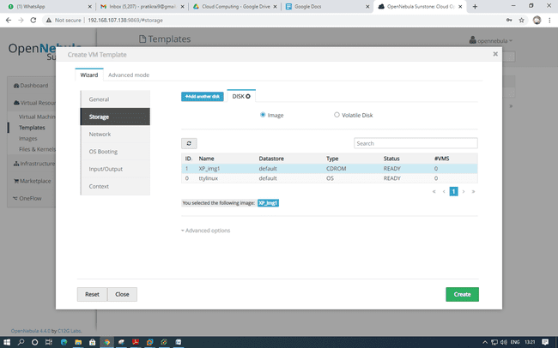

Select the network that was created.

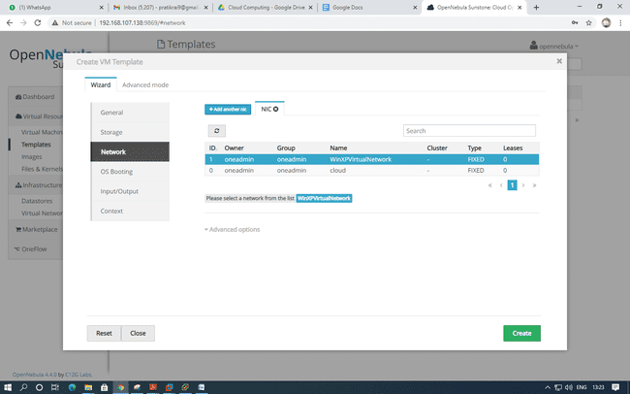

Leave Default Settings in OS Booting

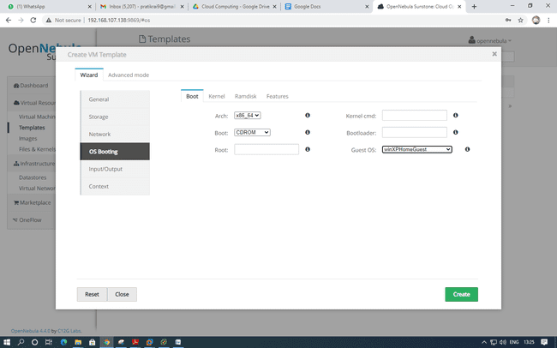

Select VNC in I/O

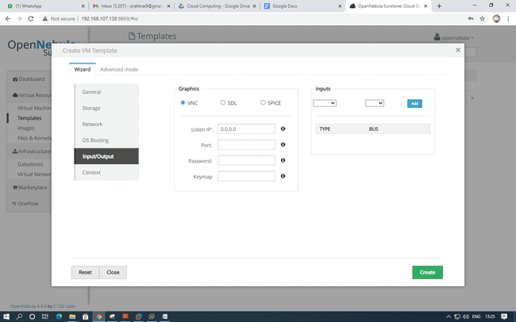

Leave it as default settings and click on create and give full rights.

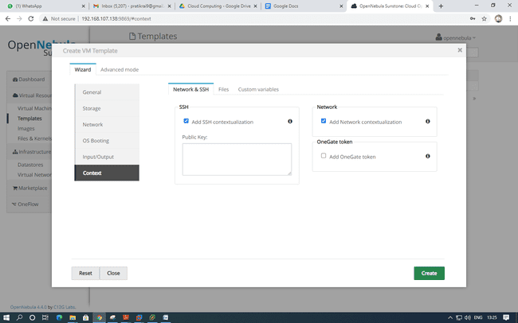

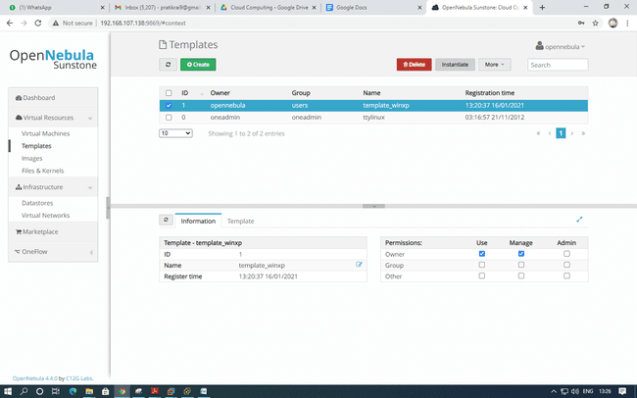

Click on instantiate

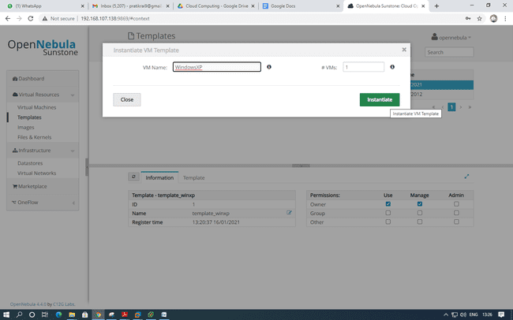

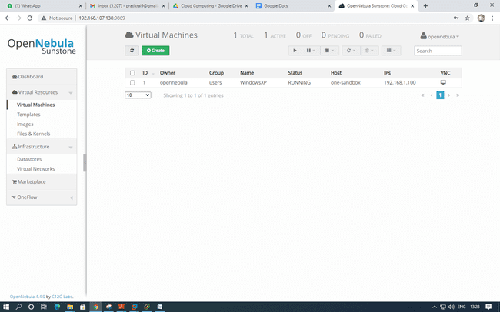

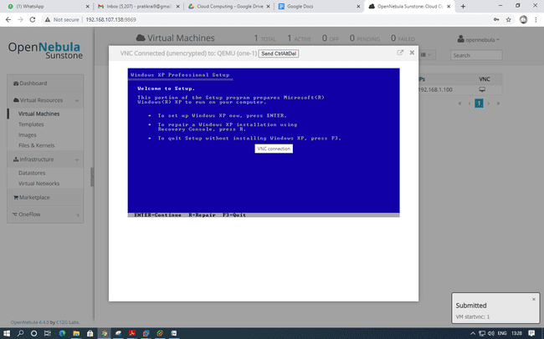

**Practical 8**

**Implementing “Big” Web Service.**

 1) Creating a Web Service

A. Choosing a Container: Open NetBeans IDE 8.2

1. Choose File > New Project. Select Web Application from the Java Web.

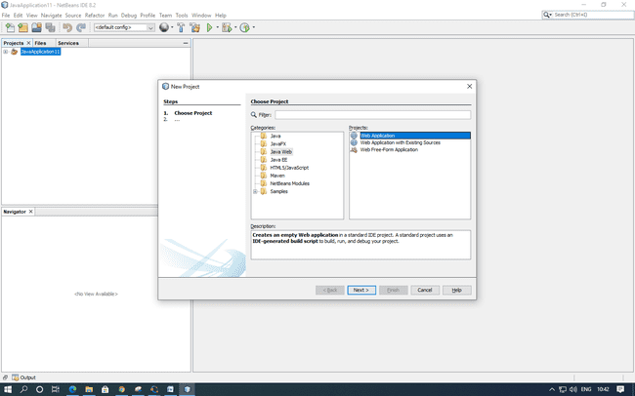

2. Name the project “CalculatorWebService”. Select a location for the project. Click Next.

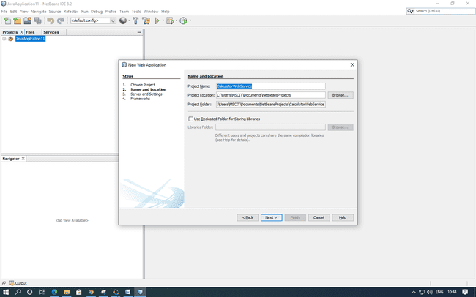

3. Select your server and Java EE version and click Finish. (Do not do anything in Framework)

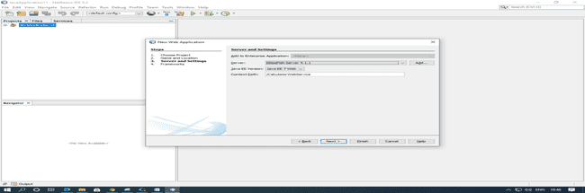

B. Creating a Web Service from a Java Class

1. Right-click the “CalculatorWebService” node and choose New > Web Service.

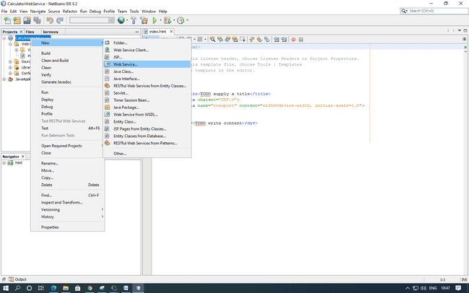

2. Name the web service “CalculatorWeb” and type org.me.calculator in Package. Leave Create Web Service from Scratch selected.

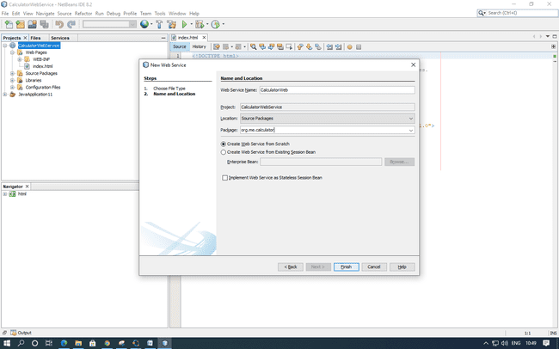

3. Click Finish. The Projects window displays the structure of the new web service and the source code is shown in the editor area.

2) Adding an Operation to the Web Service: The goal of this exercise is to add to the web service an operation that adds two numbers received from a client. The NetBeans IDE provides a dialog for adding an operation to a web service. You can open this dialog either in the web service visual designer or in the web service context menu.

A. To add an operation to the web service:

1. Change to the Design view in the editor.

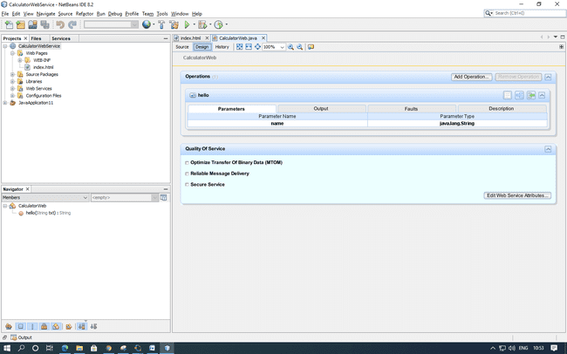

2. Click Add Operation in either the visual designer or the context menu. The Add Operation dialog opens.

3. In the upper part of the Add Operation dialog box, type add in Name and type int in the Return Type drop-down list.

 4. In the lower part of the Add Operation dialog box, click Add and create a parameter of type int named i.

5. Click Add again and create a parameter of type int called j. You now see the following:

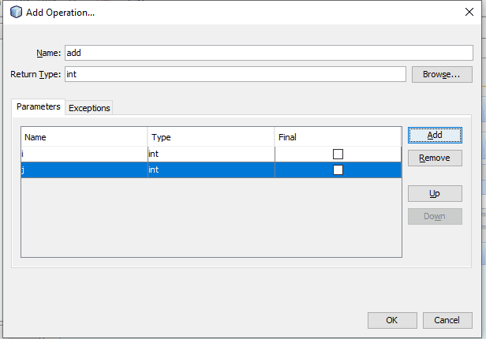

6. Click OK at the bottom of the Add Operation dialog box. You return to the editor.

7. The visual designer now displays the following:

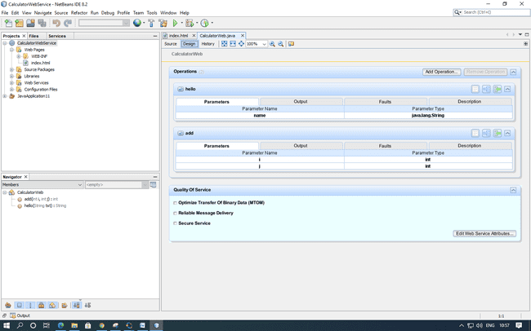

8. Click Source. And code the following.

    @WebMethod(operationName = "add")

    public int add(@WebParam(name = "i") int i, @WebParam(name = "j") int j) {

        int k = i + j;

        return k;

    }

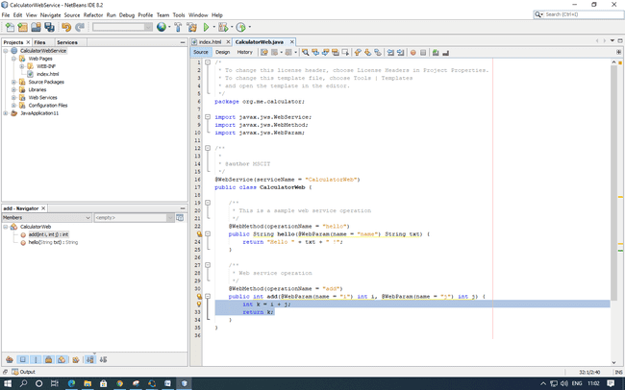

3) Deploying and Testing the Web Service

After you deploy a web service to a server, you can use the IDE to open the server's test client, if the server has a test client. The GlassFish and WebLogic servers provide test clients.

A. To test successful deployment to a GlassFish or WebLogic server:

1. Right-click the project and choose Deploy. The IDE starts the application server, builds the application, and deploys the application to the server

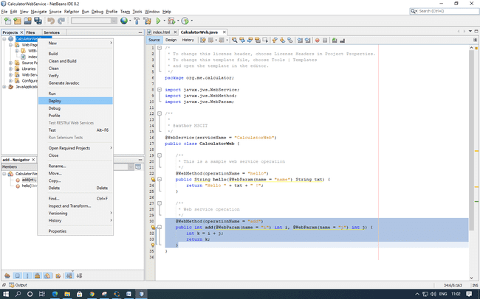

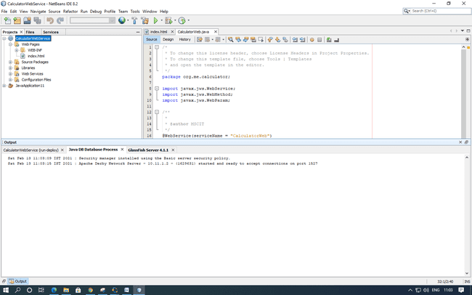

2. In the IDE's Projects tab, expand the Web Services node of the “CalculatorWebService” project. Right-click the “CalculatorWeb” node, and choose Test Web Service.

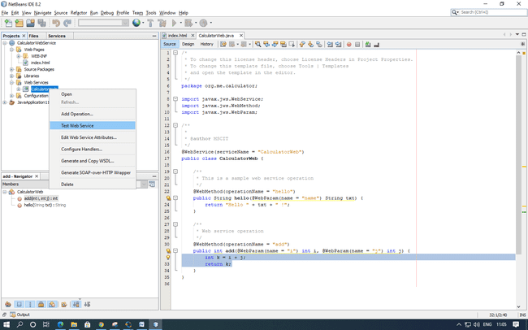

3. The IDE opens the tester page in your browser, if you deployed a web application to the GlassFish server.

4. If you deployed to the GlassFish server, type two numbers in the tester page, as shown below and press enter for output.

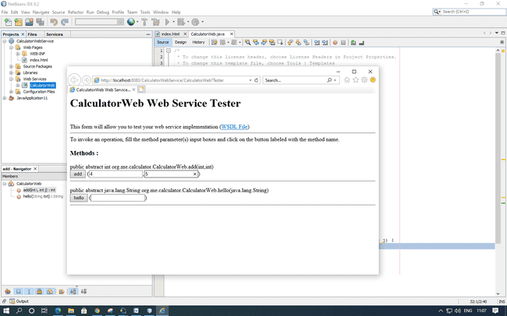

5. The sum of the two numbers is displayed:

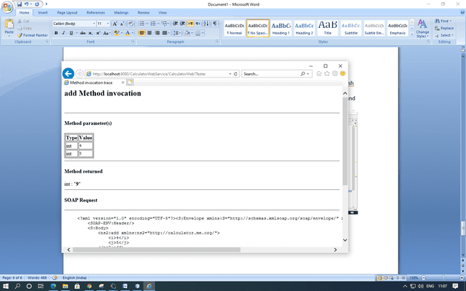

4) Consuming the Web Service

Now that you have deployed the web service, you need to create a client to make use of the web service's add method.

1. Client: Java Class in Java SE Application

1. Choose File > New Project. Select Java Application from the Java category.

Name the project “CalculatorWeb_Client_Application”. Leave Create Main Class selected and accept all other default settings. Click Finish.

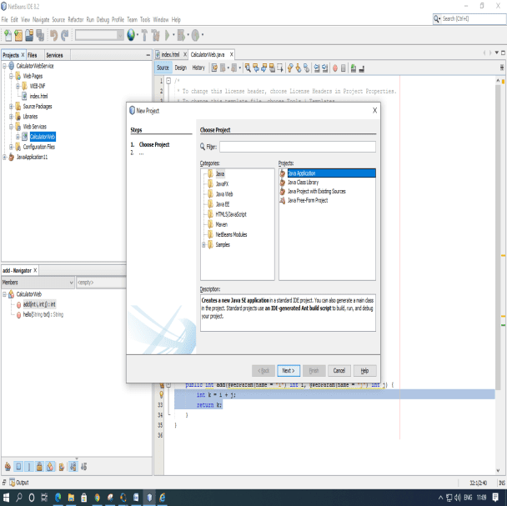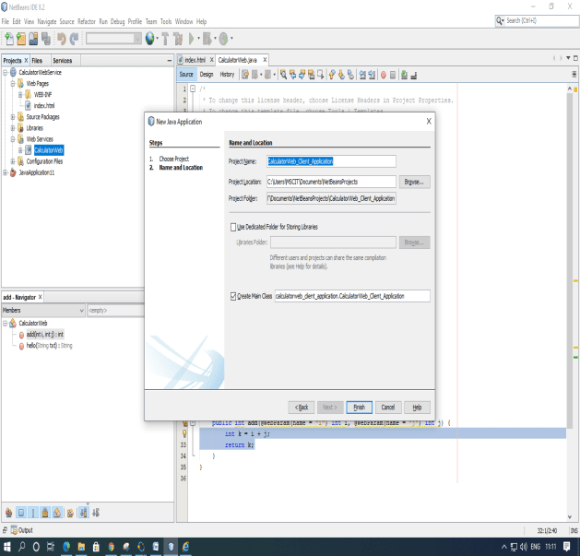

2. Right-click the “CalculatorWeb_Client_Application” node and choose New > Web Service Client. The New Web Service Client wizard opens.

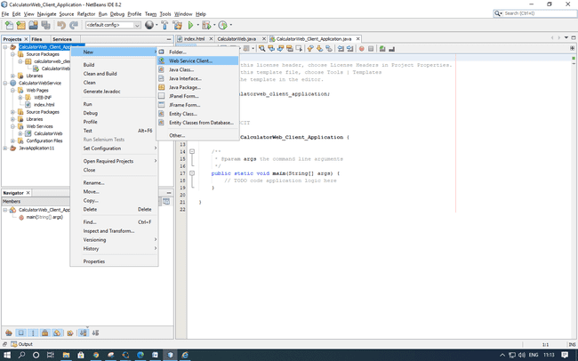

3. Select Project as the WSDL source. Click Browse. Browse to the “CalculatorWeb” web service in the “CalculatorWebService” project. When you have selected the web service, click OK.

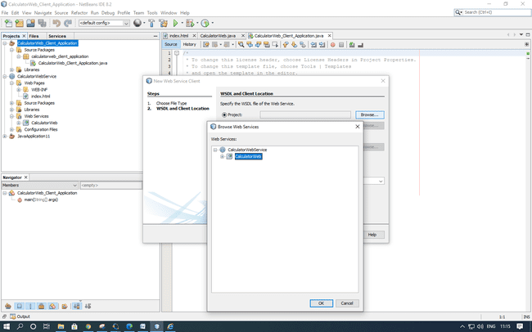

4. Do not select a package name. Leave this field empty. Leave the other settings at default and click Finish.

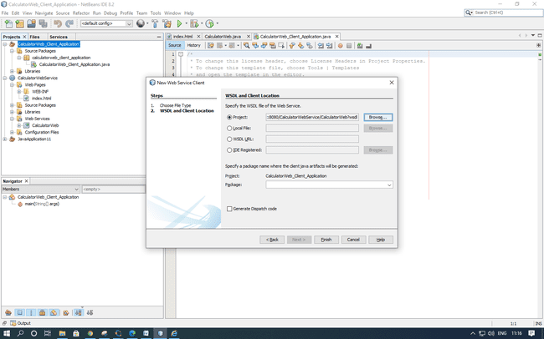

5. The Projects window displays the new web service client, with a node for the add method that you created:

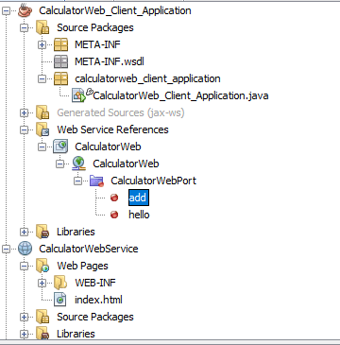

6. Double-click your main class so that it opens in the Source Editor. Drag the add node below the main() method.

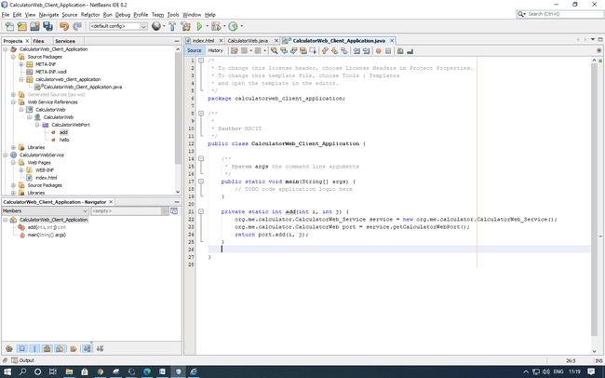

7. In the main() method body, replace the TODO comment with code that initializes values for i and j, calls add(), and prints the result.

    try

    {

        int i = 3;

        int j = 4;

        int result = add(i, j);

        System.out.println("Result = " + result);

    }

    catch (Exception ex)

    {

        System.out.println("Exception: " + ex);

    }

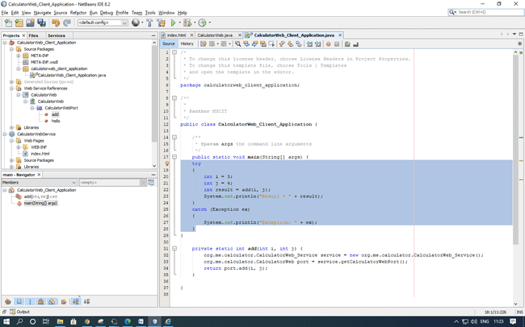

8. Right-click the project node and choose Run.

The Output window now shows the sum:

compile: run: Result = 7 BUILD SUCCESSFUL (total time: 1 second)

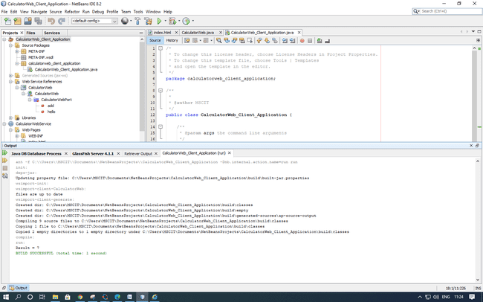

Client : JSP Page in Web Application

In this section, you create a new web application and then consume the web service in the default JSP page that the Web Application wizard creates.

Choose File > New Project. Select Web Application from the Java Web category. Name the project CalculatorWebJSPClient. Click Next and then click Finish.

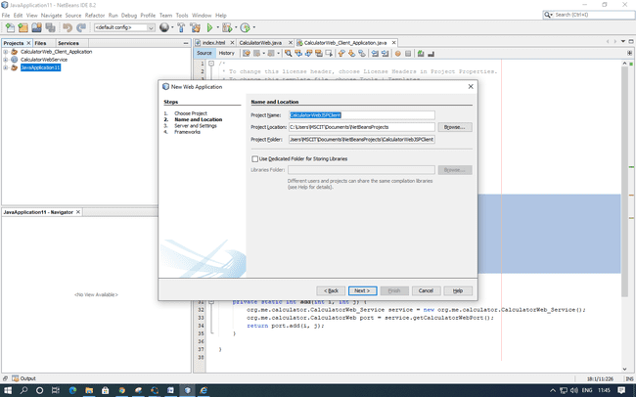

Expand the Web Pages node under the project node and delete index.html.

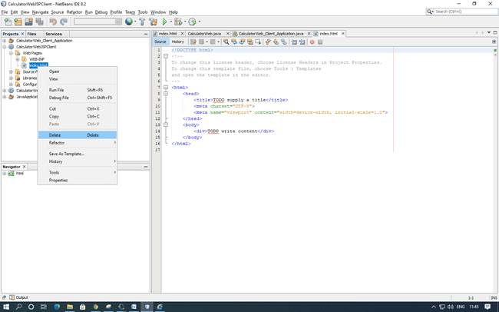

Right-click the Web Pages node and choose New > JSP in the popup menu.

If JSP is not available in the popup menu, choose New > Other and select JSP in the Web category of the New File wizard.

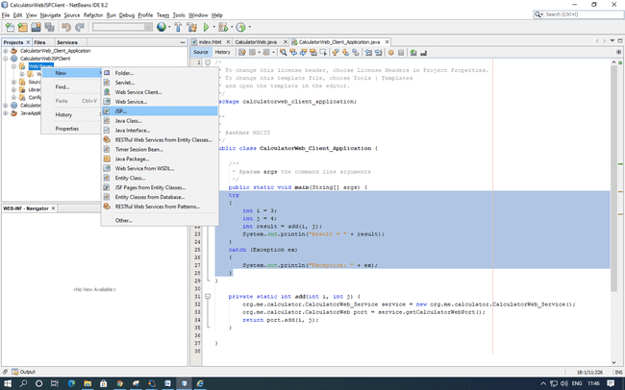

Type index for the name of the JSP file in the New File wizard. Click Finish.

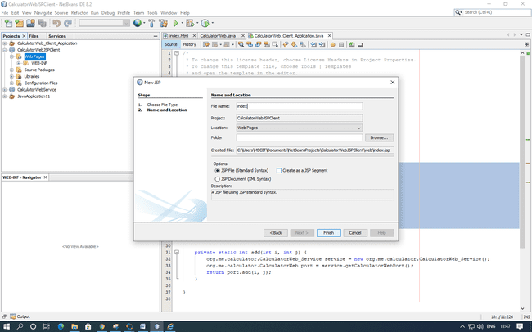

Right-click the CalculatorWebJSPClient node and choose New > Web Service Client.

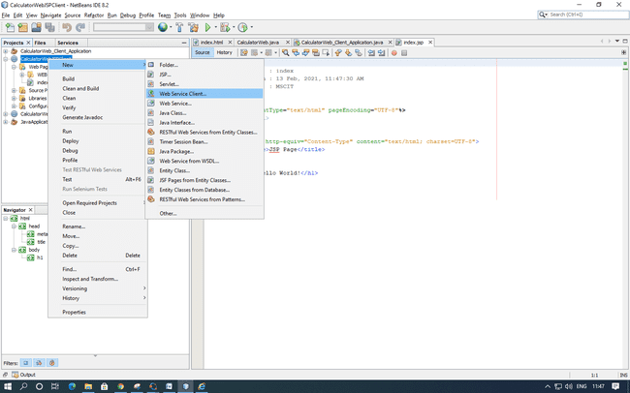

Select Project as the WSDL source. Click Browse. Browse to the CalculatorWeb web service in the CalculatorWebService project. When you have selected the web service, click OK.

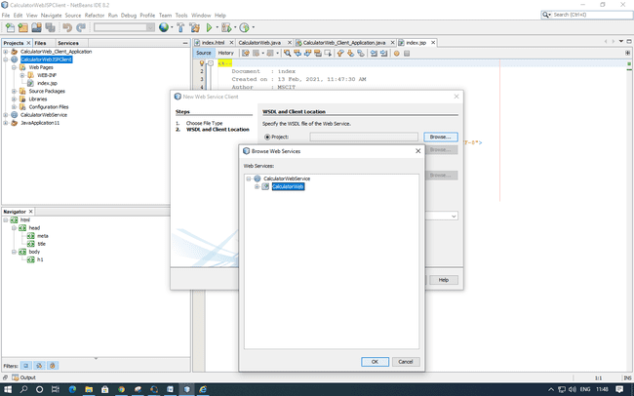

Do not select a package name. Leave this field empty.

Leave the other settings at default and click Finish.

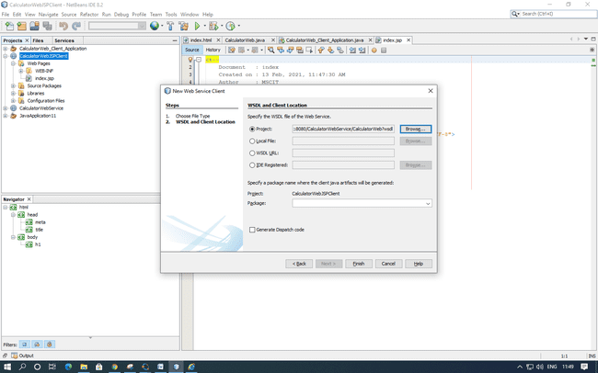

The Projects window displays the new web service client, as shown below:

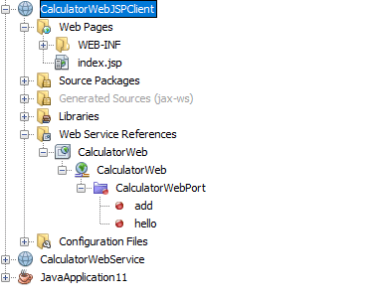

In the Web Service References node, expand the node that represents the web service. The add operation, which you will invoke from the client, is now exposed.

Drag the add operation to the client's index.jsp page, and drop it below the H1 tags. The code for invoking the service's operation is now generated in the index.jsp page, as you can see here:

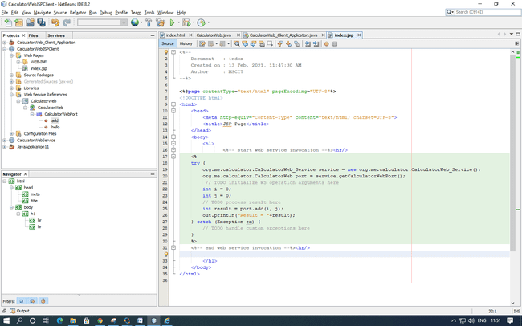

Change the value for i and j from 0 to other integers, such as 3 and 4. Replace the commented out TODO line in the catch block with out.println("exception" + ex);

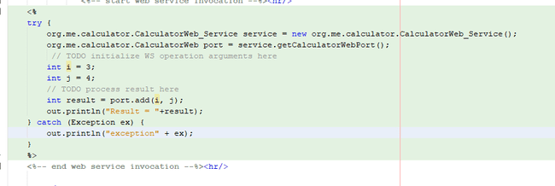

Right-click the project node and choose Run.

The server starts, if it wasn't running already. The application is built and deployed, and the browser opens, displaying the calculation result:

